1

Athlete Needs Analysis

William J. Kraemer, PhD, CSCS, FNSCA
Brett A. Comstock, MA
James E. Clark, MS
Courtenay Dunn Lewis, MA

By the early 1980, research in the field of exercise science had demonstrated that changes in specific variables related to exercise influenced the type of adaptations and performance improvements seen. The concept of acute program variables was put forth to better describe all the components of a workout (18). These acute program variables, which have been well established over the past 25 years, consist of the following:
- Choice of exercise
- Order of exercise
- Resistance used
- Number of sets
- Amount of rest between sets and exercises
It had also been established by that time that an effective training program had to be tailored to the demands placed on athletes by their specific sport (19). The many choices within each of the domains of these acute program variables required a preliminary process in order to gain information about the sport and the athlete. The concept of a needs analysis was introduced, allowing the exercise-prescription process to reflect informed choices for each of the acute program variables and to design an appropriate program for an optimally periodized training program (21). This provided a theoretical paradigm for program design for different sports and, more importantly, for individual athletes.
A needs analysis answers three general questions:
1. What are the metabolic demands of the sport?
2. What are the biomechanical demands of the sport?
3. What are the common injuries observed in the sport profile?
The needs analysis, initial testing data, and evaluations of athletes and the sport allow for intelligent program design (9), This process, along with initial testing data, helps strength and conditioning professionals examine athletes’ general fitness base, sport-specific fitness, and injury history, as well as the physiological and biomechanical demands of the sport and its potential risk for injury. By gathering this preliminary information, they can make informed choices in regard to program design, tests needed to monitor progress, and other evaluations necessary for athletes in a given sport (2). This allows them to better understand the needs of the strength and conditioning program and to develop a set of appropriate training goals (9). Thus, the ultimate goal of needs analysis is to develop a total conditioning program to improve athletic performance and reduce injuries (21).

Metabolic Demands of the Sport
Not all sports are performed under the same metabolic conditions. The predominant metabolic pathway varies depending on the demands of the sport; it can also be specific to the muscles being used. When a muscle is activated in the recruitment process to produce force, the amount of energy used and the predominant energy system source vary, yet most sports have an inherent, recognizable metabolic profile that ranges in nature from highly aerobic to highly anaerobic, As table 1,1 demonstrates, aerobic endurance and ultra endurance events (e.g., marathons or triathlons) are at one end of the spectrum, and very short-duration or explosive strength/power events (e.g., shot put, maximal clean and jerk) are at the other end. In between these two extremes are sports that use a combination of these metabolic systems during competition. Metabolism changes rapidly based on external demands, allowing dramatic shifts to the anaerobic system when sprinting and then to the aerobic system during recovery (e.g., a soccer player sprinting down the field and then jogging back to position when the ball goes downfield). Table 1.1 presents the general profile of energy dominance for various sports.
Although an emphasis on metabolic training appears to exist in the athletic realm, it is important to carefully evaluate the actual metabolic demands of the sport prior to prescribing exercise. The metabolic demands can be estimated as a total metabolic profile of the sport. One can estimate what the predominant metabolism will be for the primary muscles used, based on a time-motion analysis of the sport. For example, baseball's metabolic demands are predominately related to the ATP-CP system; thus, short rest programs that place high demands on the lactic acid system (Glycolysis) are really not needed (9, 21, 26).
Many training programs related to developing maximal strength and power requires athletes to be rested and recovered when performing the workouts (20). Therefore, a program that places high demands on the lactic acid system and leads to fatigue can compromise other aspects of training. The often-prescribed short rest protocols are only one style of training within the multitude of workouts that can be designed for athletes. Thus, sport- specific conditioning should include attempts to train the same metabolic systems used in the sport. Furthermore, this method allows athletes to express strength and power within the context of metabolism for their sports. Adenosine triphosphate (ATP) is the body’s energy molecule. It is produced by the anaerobic and aerobic energy systems. All muscle fibers use ATP molecules as a source of fuel during exercise to produce chemical and, eventually, mechanical energy. ATP is a crucial requirement in the sliding filament mechanism of muscular contraction that produces force. Primary concerns in sports include the amount of ATP energy required, how rapidly it must be available, and whether the metabolic conditions present can be tolerated. Thus, conditioning programs should place a major emphasis on improving capabilities to produce energy and tolerating the associated metabolic demands of the sports (e.g., compare a 100 m race, an 800 m race, and a marathon).
Generally, the physiology of a sport can be described by the energetic demands of the sport (i.e., aerobic or anaerobic). Although different sports may be classified as aerobic or anaerobic, it is important to remember that no sporting competition will tax a single energetic system alone (see figure 1.1). Additionally, the idea of energetic can be extended further to include sprint, strength, power, and cardiorespiratory (aerobic) endurance sport. As athletes move through this cascade of energy and fuel systems, the level of oxygen required within the system goes from low (none needed to perform a given skill, such as lifting a heavy weight one time) to high, being predominantly dependent on the aerobic system for ATP production in order to sustain the activity (e.g., running a marathon).
The energy systems utilized by the body in training or during a sport are as follows:
- Phosphagen (ATP-CP system)
- Glycolysis (lactic acid system)
- Krebs cycle or citric acid cycle (aerobic system)
The ATP-CP system immediately supports muscular contraction, since it uses energy obtained from intramuscular stores of adenosine triphosphate (ATP) and Creatine phosphate (CP). This system is typically utilized during short-duration, high-intensity physical activity. The other anaerobic system, more commonly known as the lactic acid system, is called Glycolysis. Glycolysis results in ATP production from the breakdown of glucose in the sarcoplasm of muscle fibers. The glucose can be obtained from either blood glucose or intramuscular stores of glycogen. Therefore, it is a less rapid source of ATP energy than the ATP-CP system.

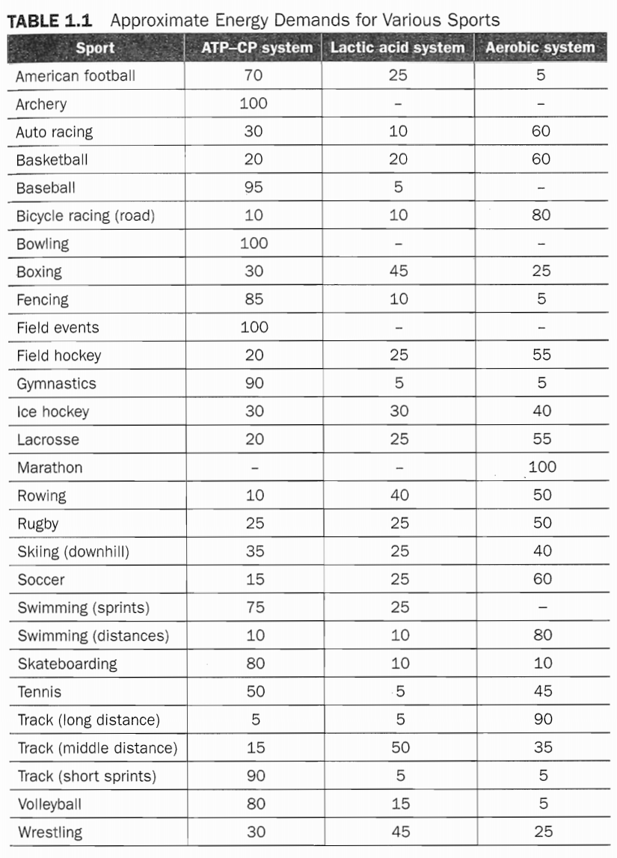

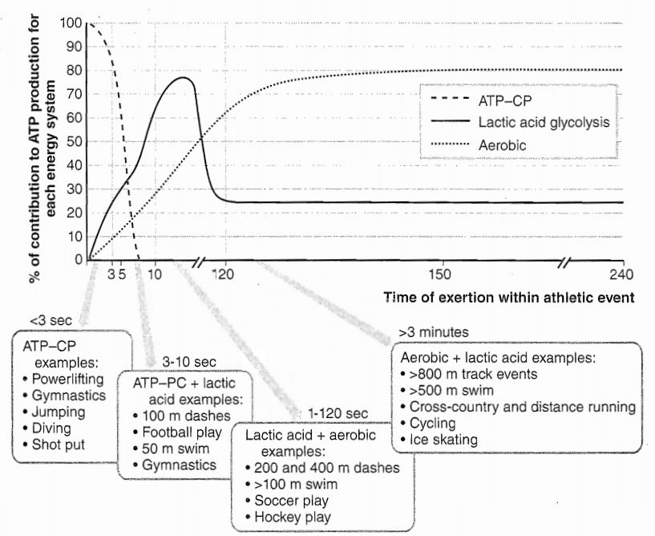
FIGURE 1.1 Contributions of the three energy systems to athletic performance over time. As the duration of a movement increases, the primary energy system at work shifts from the ATP-CP system, to the tactic acid (Glycolysis) system, and. finally, to the aerobic system.

Most often referred to as the Krebs cycle or the citric acid cycle, the aerobic system is the most robust system for producing ATP energy, yet it is the slowest in getting ATP to the active musculature, The aerobic system is obviously very important for performing cardio respiratory endurance activities, due to its ability to produce large amounts of ATP without generating fatiguing products, It differs from Glycolysis in that carbohydrates, fats, and proteins can all enter into the aerobic cycle for breakdown and the eventual production of ATP through the electron transport system in the mitochondria.
Generally, the ATP-CP cycle begins to fatigue and exhaust itself roughly 6 seconds after exercise is begun. Once exercise duration extends beyond this time, the glycolytic pathway begins to take over, providing the energy required for the athlete to continue. However, the glycolytic pathway is a short-lived energy system, lasting only a few minutes. This means that if the exercise intensity allows athletes to sustain activity for longer than a minute or two, then they need to shift predominantly into the final energy system (aerobic metabolism) for support, even When exercising intensely.
Regardless of the sport and the position played, athletes must be able to meet, and preferably exceed, the metabolic demands for the sport. This simply means that athletes need to be able to withstand the stresses (metabolic, biomechanical, and physical) of the sport for the duration of competition. A properly designed training program should have metabolic demands that approximate those of the sport. However, because of the timing of individual movements within the event, custom exercises that increase the ability to tolerate metabolic demands may need to be prescribed. For example, consider the large differences in metabolic demand between a midfielder and a goaltender in soccer or between a forward and a goalie in ice hockey. The conditioning program should be specific to the physiological analysis of each position.
In order to determine the most appropriate training and testing protocols and requirements for individual athletes, the balance between the energy systems and fuels used within a sport must be understood. Some workouts within a periodized training program should mimic the sport metabolism. For example, wrestlers need to develop strength and power, but they also need to perform conditioning activities that utilize short rest periods in order to develop buffering capabilities so that they can express their maximal muscular strength and power under the metabolic conditions of the sport (i.e., high levels of lactic acid and lower blood-pH values) (24). This is why an effective training program must incorporate a variety of workouts and why different athletes require different programs (9).

Biomechanical Demands of the Sport
The next step in the needs analysis is a basic biomechanical assessment, based on the types of generalized body and limb movements that are encountered during an athletic event. This includes the position of the body in space, the timing and coordination of various parts of the body needed to execute the desired movements, the speed of the athlete’s body (or parts of the body) during the desired movement, and the length of time of exertion for the athlete (6). Along with an examination of the primary muscle actions used and the planes of motion in which they take place (i.e., sagittal, frontal, transverse), strength and conditioning coaches can examine the pattern of movement, the joints involved during competition, the pattern of muscle actions, and the planes of movement in which actions take place.
By undertaking this very basic biomechanical analysis of the athletic movements required for the sport, a strength and conditioning professional can determine key aspects of the movement, including the type of movements involved, the range of motion (ROM) of joints during activity, the required speed of movement, the pattern of muscle action during movements, and the metabolic demands of the sport or event based on the length of time of each exertion within the athletic event (34). These factors are important when it comes to choosing exercises to be used in a resistance training program. This analysis of the planes of motion and the type of muscle actions used will help strength and conditioning professionals choose resistance exercises that are biomechanically similar to the demands of the sport. From these generalized patterns of movement, they can focus on the specific movements required to perform various sport skills.

Describing Sport Movements
The general pattern of movement will be described as either static or dynamic within a specific plane or planes of movement (34). Within dynamic movement nomenclature, movement can be further described as either open or closed (34). When the movement is open, the hand or foot will be free to move and the body will remain relatively static (see figure 1.2). In a closed movement, the hand or foot is relatively static and the body moves relatively freely (see figure 1.3).
Three primary types of muscle actions are used in sport skills (isometric, concentric, and eccentric). Isometric action results in no change in the length of the muscle (the muscle produces force that is equal to the force being applied to the bony attachment of the muscle). The concentric movement of the muscle decreases the length of the muscle (the muscle produces more force than is being applied to the bony attachment of the muscle). Eccentric movement results in a lengthening of the muscle (the force applied to the bony attachment of the muscle is greater than the force produced by the muscle). An understanding of these three types of action will ensure that exercises are achieving the desired effect.
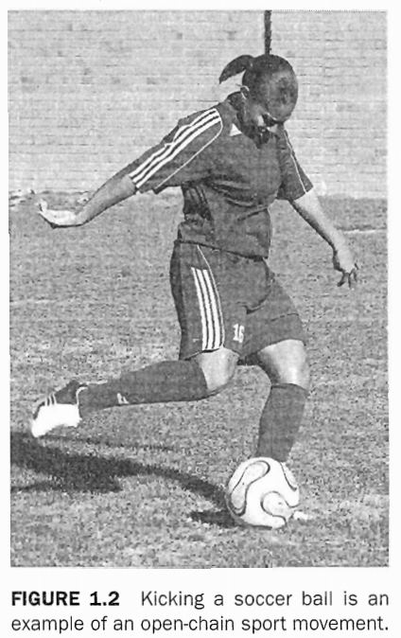
Along with the type of movement, another consideration is the speed of movement, or angular velocity of the involved joint. The description for speed of movement is generally given in reference to limb movement or rotational speed of the body around a central (vertebral) axis (34), Although accurately measuring speed of movement requires sophisticated equipment, strength and conditioning professionals can use their best judgment to estimate the rate of speed that athletes need to utilize in the sport. The important issue with the analysis of speed of movement is to observe joints that are vital to movements within the action. For a majority of athletic movements, this entails observing speed of movement at the hip, knee, or ankle of the leg and at the shoulder, elbow, wrist, or hand of the arm (34). Further, attention should be paid to the positioning of the trunk and the movement of the torso throughout all athletic movements (6, 33, and 34).
In addition to the type and speed of movement, there must also be consideration for the speed of muscle force development that is required both for performing athletic movement and stabilizing the torso and body throughout (6, 33) (e.g., holding the torso upright during a spiking motion in volleyball). Through careful analysis of the movement patterns, strength and conditioning coaches can determine and distinguish when the muscle action is causing a movement to occur, stabilizing the body in a static position, or controlling the loading of a limb from external force (33, 34). It can be generally understood that the acceleration of the body or limb of the body will be done through a concentric contraction, while the deceleration of the body or limb of the Body will be done through an eccentric contraction (34), when the body or limb is being stabilized without movement; the contraction type is considered to be isometric (34).
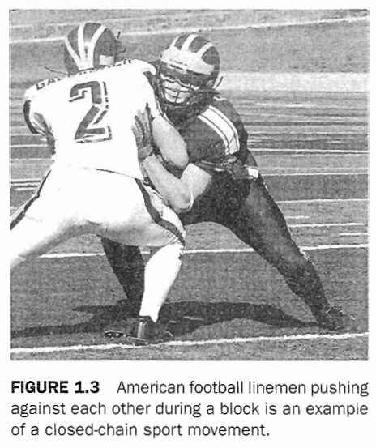
Furthermore, by analyzing movements and muscle actions within the athlete's sport, strength and conditioning professionals can also determine the energy system being utilized (27). They can use motion analysis to determine the length of time for each of the individual points of exertion so that the conditioning program can match the energetic demands of the sport (3, 5, and 23). The area of interest for strength and conditioning professionals with this type of analysis is to determine the amount of time that the athlete will be actively engaged in an athletic movement during a sporting event. This analysis gives them a guide to follow for establishing the metabolic demands for the conditioning program as it relates to time of exertion, amount of rest time available within a sporting event, and the type of muscular forces the athlete is required to produce (e.g., a shot put versus a wrestling match versus a 10K race). From this time analysis, strength and conditioning professionals can manipulate various training variables to generate regimens that provide both the neurological and metabolic stresses (3-5, 7, 23) that allow adaptations related to the needs of the sport to be made (19, 32).

Biomechanical Analysis in Practice
For the purpose of understanding the movement being analyzed, strength and conditioning professionals should use the following four questions. First, what are the patterns of movement (i.e., concentric, eccentric, or isometric), and in which planes do they take place? Second, what joints are involved during the activity? Third, what muscles are recruited, and what are the muscle actions? Finally, what is the duration of time that the athlete will be actively engaged in the athletic event? With these key questions, strength and conditioning professionals can determine the demands placed on the body during the sport (6, 33, and 34). The ultimate goal of analysis is to manipulate and match the acute variables that govern the program's design to match the metabolism and movements involved in the sport.
Typically, biomechanical evaluations require strength and conditioning professionals to analyze videos of athletes performing their sports. Those without access to advanced video equipment can accomplish this type of analysis by watching simple video of athletes during practices or games. The following are some very basic procedures for video analysis that strength and conditioning professionals can follow (9).
- View a video of an athletic performance or activity.
- Select a specific movement in the sport (e.g., a jump shot in basketball or a takedown in wrestling). To completely analyze the sport, several movements or skills may need to be examined. Look at the entire sequence of competition to get a feel for the demands of the sport.
- Identify the joints around which the most intense muscular actions occur, Running and jumping, for example, involve intense muscle actions at the knee, hip, and ankle, Intense exertion doesn't necessarily involve movement, Considerable isometric force may have to be applied to keep a joint from flexing or extending under external stress.
- Determine whether the movement is concentric, isometric, or eccentric,
- For each joint identified above, determine the range of angular motion, Observe how the joint angle changes throughout the movement and which plane it occurs in.
- Try to determine where the most intense effort occurs within the range of motion around each particular joint. Sometimes facial grimaces or tense muscles seen on video can help identify points of peak intensity.
- Estimate the velocity of movement in the early, middle, and late phases in the range of motion. If using video, determine the time between frames to examine the movement over the time of the activity.
- Select exercises to match the limb's ranges of motion and angular velocities, making sure that the exercises are appropriately concentric, isometric, or eccentric.
Through this type of biomechanical analysis, strength and conditioning professionals can make sure that training programs reflect these demands (see table 1.2).
It is important to remember that although analyzing sporting movements and matching the proper exercises in the weight room are vital to the sport-specific nature of resistance training programs, many exercises might be considered universal in that all athletes need them. These exercises include squats, pulling motions (e.g., hang cleans), and presses, such as the bench press. Such exercises provide the core around which a program is built, Integration of whole-body, multijoint exercise movements is vital because single-joint exercises alone cannot improve neurological coordination between joints.

Injury Risks of the Sport
Before discussing injury prevention and how to use a needs analysis to design a program that diminishes the risk of injury, it may be important to step back and review some of the basic concepts of injury and risk for athletes (3, 5, 7, 18, 19, 27). Although it may be defined in many ways, an injury is generally any trauma to the body. In athletics, the majority of injuries affect the musculoskeletal system (bones, ligaments, muscles, and tendons), while additional injuries may include the neurological and cardiopulmonary systems (concussions, asthma, and heart attacks). For the most part, an exercise regimen can be designed by analyzing the biomechanical and metabolic demands of the sport and using this information to reduce the risk of injuries that can occur. Although risk of injury can be diminished through needs analysis, proper programming, and periodization of training programs, it must be remembered that sometimes injury is unavoidable.
Musculoskeletal injuries can occur due to either mechanical overload or repetitive overuse of a joint, limb, or muscle group. Mechanical overload injuries can be categorized as contact (two athletes hitting each other or an object hitting an athlete) or noncontact (athlete is injured without direct contact with another athlete or object). All types of injuries can be addressed within proper exercise program design, but they will be addressed in different fashions based on the exercises utilized to reduce the risk for that particular type of injury.
Regardless of the type of injury, most injuries seem to coincide with two factors. First, injury occurrence increases when an athlete becomes fatigued. Second, the rate of injury increases when the athlete experiences tissue fatigue (where the joint, bone, ligament, tendon, or muscle cannot respond to the forces placed on it), this phenomenon can be thought of as a fatigue-induced cascade of events, which begins with fatigue of either the central or local tissue and results in injury (1, 2).
In terms of biomechanical demands, injury prevention should be based on how accidents typically occur in the sport. Two primary means exist for athletic injury in sports: contact injuries and noncontact injuries. The difference between the two is not the type of injury that the athlete may suffer; it lies in the mechanism of injury. All contact injuries come from a limb or joint being exposed to an excessive load that is caused by an external force (e.g., a tackle in American football hits a knee). From this excessive load, the tissue around the limb or joint fails to meet the demand and becomes injured (most notable are fractures to bones or ligament ruptures). Most noncontact injuries occur during an acceleration of movement (either speeding up or slowing down). They are more readily seen in the change of direction movements that occur at various points within a competition (e.g., a running back in American football who is changing direction
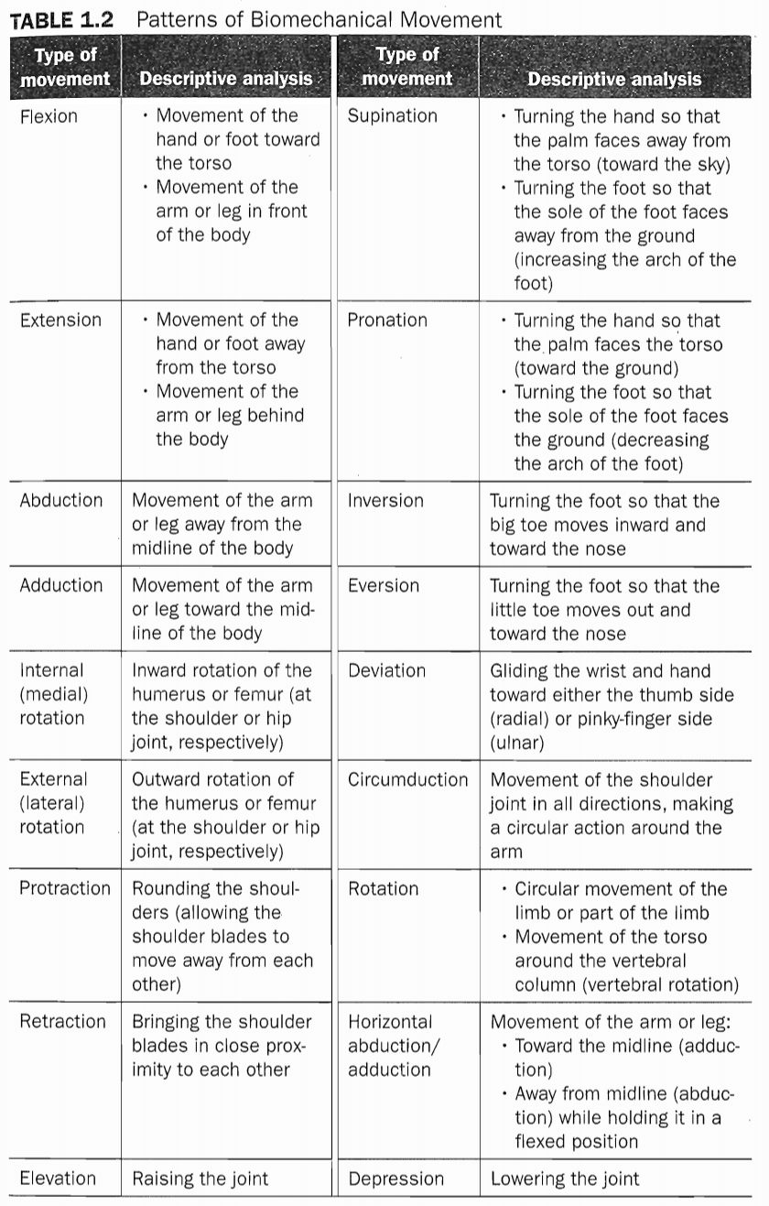
plants his leg while moving at full speed). Outside of acceleration, noncontact injuries also occur through overuse of certain muscles, muscle groups, tendons, or ligament structures of the body, based on the demand of the sport.

Needs Analysis for Injury Prevention
Regardless of the sport, a cascade of events often eventually leads to injures (see figure 1.4). For example, for wrestlers, reducing fatigue or learning to better tolerate the fatigue processes during practice and competition is the easiest way to prevent injury (29, 36, and 37). By understanding the means by which athletes encounter risk, strength and conditioning professionals can integrate exercise programs that may offset one of the steps toward injuries (e.g., short rest circuits for Wrestlers help them develop buffering capacities to offset the decreases in pH that are related to fatigue).
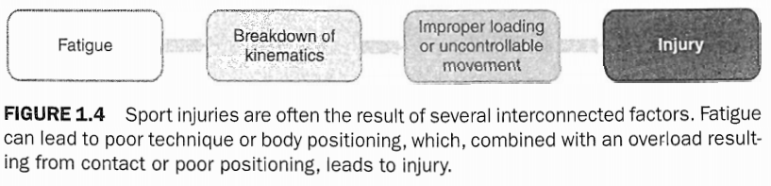
When determining how injury prevention fits within the needs analysis of a sport, strength and conditioning professionals must ask the following questions. First, how likely is an injury to occur in the sport? Second, what are the common injury sites and how are these injuries most likely to occur? Third, which athletes are most prone to these risks for injury? Fourth, how can an exercise program be developed that will diminish these risks? This is where strength and conditioning professionals can work with athletic trainers and team physicians to get a handle on each athlete’s injury or medical status and to integrate a training program for injury prevention.
The role of prevention within athletics is to design programs that address the need for reducing the risk of injury during competition. This is truly a team approach; it needs to combine the skills and knowledge of the team physician, the sports medical staff (i.e., athletic trainer and physical therapists), the strength and conditioning professional, and the sport coaching staff. Within this team approach, the overall needs analysis should focus on the general concept of what an injury is and how it occurs for a particular athlete, all the while addressing the following questions as they relate to that specific person:
- How is the athlete predisposed to injury within the sport?
- Is this athlete at greater risk based on a predisposition to injury?
- When will injuries most likely occur during the athletic event?
- Is the athlete recovering from an acute or chronic injury that can affect athletic performance?
Biomechanical observations show where the athlete is most at risk for injury, based on the demands of the sport. They will also demonstrate how to counteract the risk of injury through strength training. Strength and conditioning professionals must keep in mind that although different sports may have similar injury profiles, each sport has different demands that change the required training stimuli athletes need to encounter during training to decrease the risk for injury. Table 1.3 shows some common injuries by sport and position.
This part of the analysis should include a careful examination of the individual athlete’s injury and training history. Does the athlete reflect or deviate from the expectations of the sport in terms of past injuries? Some athletes are more or less prone to injury than others. In addition, evidence-based predictions of injury that use testing or profile parameters (e.g., body fat, exercise performances, core strength) are an emerging trend in athletic training that should he discussed with the athletic trainer and included in a needs analysis.
The strength and conditioning professional and athlete should also use the injury-prevention portion of the needs analysis to develop testing methods for aspects of sports performance that are not normally addressed in other phases. This additional portion should examine passive, static, and dynamic ranges of motion that the athlete is able to attain in many positions. Such analysis can be done by having the athlete perform various exercise-related movements while the strength and conditioning professional notes a deficit in the athlete's ability to attain the desired range of motion. Additionally, the strength and conditioning professional should take time to analyze the athlete’s movements during training in the weight room. This will provide insight on the athletes’ movement patterns, both statically and dynamically. The strength and conditioning professional will then be able to prescribe the exercises that will best address deficits in the desired muscle action, posture, or ROM (2).
When the risk of injury within a sport is combined with its biomechanical analysis, this information allows strength and conditioning professionals to set definable risks of injury based on the athletic position within a sport (2). For example, baseball pitchers are typically at a greater risk for elbow and shoulder injuries (primarily due to overuse) than first basemen. The relationship between gender and the risk of injury has left room for debate (4, 5, and 28). However, trends for gender difference in injury rates within a sport do exist. Using the type of injuries that occur based on gender, sport, and position played, exercise protocols can be implemented to minimize the risk of properly periodized training programs.
With the advent of pretesting and training preparation for athletes, many strength and conditioning professionals have been pushed outside of their realm of expertise. They may need to work with members of a sports medicine team (e.g., team physician, athletic trainers, and physical therapists) to integrate measures that might allow them to better manage the chance of injury for each athlete by using evidence-based medical practices for identifying risk. As previously noted, this is an emerging science within athletic medicine. Strength and conditioning professionals should use this information to enhance the adaptations of each athlete at risk by incorporating exercises into the program to achieve higher adaptations (e.g., improved core strength, improved upper back strength, improved body composition, and so on) (10). This will provide the prehabilitatian effect often referred to in the sports medicine community (30).
By using this information, any strength and conditioning professional can use a needs analysis to establish an injury-prevention program that will ultimately improve the strength and endurance of athletes' musculoskeletal and cardiorespiratory systems. This approach will also prevent fatigue and injury within the body.

Athletes Recovering From Injury
Athletes recovering from an existing injury may require the manipulation of training stimuli in multiple directions within a single program (21, 23). For example, the program may be able to make athletes bigger, faster, and stronger, despite their inability to perform full squats due to a prior knee or ankle injury. Recovery from injury requires making adjustments in the training regimen that will allow healing from the tissue trauma. As previously stated, in this situation, sport coaches need to use the sports medicine team (team physician, athletic trainers, physical therapists, and the strength and conditioning professional) to appropriately recognize and apply the training stimulus that the athlete will need to both recover from the injury and to improve performance (21, 23, 35).

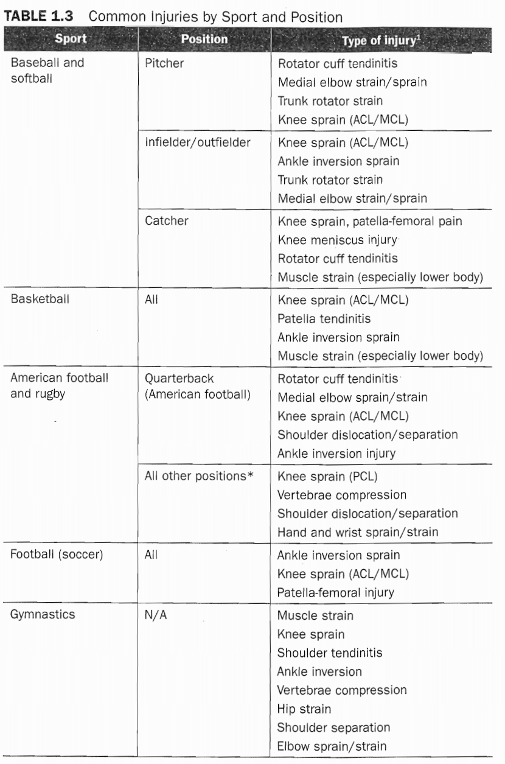

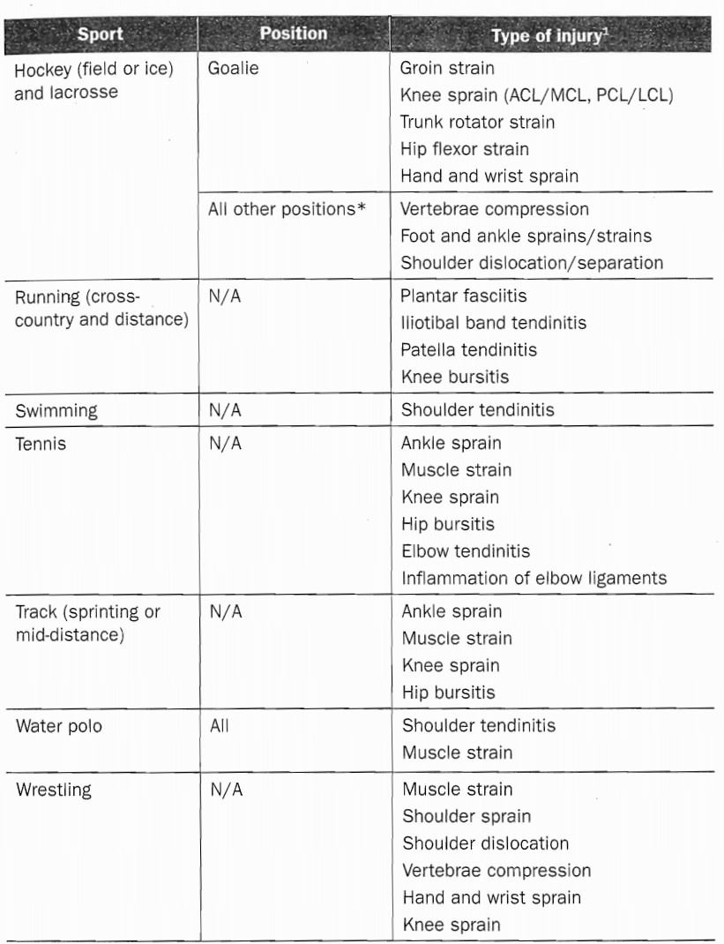

Strength and conditioning professionals must examine both the training history and the injury profile of each athlete. This examination should involve input from all members of the sports medicine team who are involved with the injury-prevention portion of the program. Furthermore, by knowing the training history and injury profile, the strength and conditioning professional can adjust exercises, as previously mentioned with the squatting example, so that the athlete can still participate in training without causing further stress to the body (25).

Integrating the Needs Analysis
Before designing a training program, strength and conditioning professionals must consider the needs of the athlete based on the demands of the sport, position played on the team, genetic and morphological differences, and any previous injuries or medical conditions (13, 15-17). One key aspect to remember when developing the training program is the athlete's training history. The first aspect of this assessment is to catalogue previous training and the point in the training calendar when the athlete begins training. In completing this assessment, the strength and conditioning professional should talk with athletes to determine what they have been doing in their previous strength training, their athletic history, their injury history, and any other questions that may seem pertinent to forming a comprehensive background profile. Testing is also important to assess sport-fitness status, develop injury-prediction models, motivate athletes to improve or maintain a given fitness parameter, examine the effectiveness of a conditioning program, and to motivate athletes to take responsibility for their physical development in order to prevent injuries and improve their physical potential and performance. The maturity of the athlete and the amount of prior training and competition will affect the comprehensive approach.
The strength and conditioning professional is faced with the realities of the length of time allotted to train, the facilities available, and the training goals of each athlete (9). These goals should always be based in facts and scientific data, not simply in philosophy. The best indicator of how well programming goals have been met is to evaluate how closely the training program matched the demands of the sport. Training variables must be manipulated so that training is specific to the muscle actions, muscle groups, movement group, velocity, and energy system required for the sport. It sounds intuitive to say that a training program should focus on the areas the athlete wants to improve, this concept is generally accepted, and yet it is sometimes ignored. The needs analysis will help determine the needed areas of emphasis.
With a full understanding of the physiological demands of the sport, the strength and conditioning professional can develop a program that will enhance the athletes’ physiological capacity for the sport, yet not push them into a pattern of overuse that can set them up for injury. Again, knowledge of the athletes' personal and competitive schedules and the use of periodized training are vital in this process. This is especially important when sport governing organizations (e.g.,, National Collegiate Athletic Association) limit practice time. Thus, sport coaches may be forced to compete with the strength and conditioning professional for valuable training time.
Too often, sport coaches do not allow appropriate time for rest and recovery, consequently overloading athletes with too much practice (e.g., often soccer [football] coaches scrimmage too much and spend too much time with running conditioning drills, sacrificing time for strength and power training), This behavior may predispose athletes to overuse or noncontact injuries by reducing the body's time to repair and recover from the stresses of exercise and activity, By analyzing the exertion-to-rest intervals, the strength and conditioning professional can determine which types of exercises can help develop both athletic prowess within a competition model and methods for recovery within and between competitions. Identifying the potential recovery problems is part of the process. From that point, solutions must be devised to ensure the athlete can meet the demands of practice, competition, and recovery.
Now that the foundational information concerning metabolic demands of the sport, biomechanics, and injury prevention has been reviewed, this information must be used in each athlete's workouts and conditioning program. Strength and conditioning professionals have a multitude of information to gather and consider. It is their duty to spend time understanding the fundamentals, putting them into practice, and re-evaluating and changing the program to meet the demands of various sports.

Functional and Nonfunctional

Overreaching and Overtraining
Strength and conditioning professionals must manipulate exercise selection and tailor training stimuli to attain the desired adaptations for a particular sport (9, 23). When training variables and exercise selection are manipulated, a stimulus is created that varies based on the goal of training (i.e., hypertrophy, power, strength, local muscular endurance, or capacity for cardiorespiratory endurance of the musculoskeletal system), This forces the athlete to adapt in response to the training program through neurological, structural, and hormonal changes, These changes are only achieved by stressing the athlete beyond comfort levels (typically called overload).
By providing overload in the training program, strength and conditioning professionals ensure that the athlete will functionally overreach within the training program and progress as expected (11, 12, 14), Thus, a staircase effect results. The athlete experiences acute fatigue and a temporary reduction in performance, but quickly returns to normal or even slightly increased function (9). With long-term overreaching, the body's functional capabilities may be suppressed for several days. However, they rebound (i.e., increase beyond pretraining values) dramatically when the overreaching stimulus is removed (31). Here, the strength and conditioning professional is in control of this positive adaptation, or the structural and functional differences that occur with training (37).
The manipulation of training variables is a delicate balancing act. Close monitoring of both workout logs and testing is required. If manipulation of the training variables is not tailored correctly to the desired adaptations and specific training goals, the athlete will experience symptoms of nonfunctional overreach. In this scenario, the athlete's body will have the same neurological, structural, and hormonal responses to exercise as with functional overreach, but he will be unable to positively adapt without rest, Performance will begin to suffer and some training adaptations may be lost. This means that the total conditioning program is flawed and that the athlete is not successfully adapting or maintaining functional capabilities or body composition (22), If this process continues, the athlete can enter into an overtraining syndrome, and may need months to recover performance capabilities (11) (see figure 15).

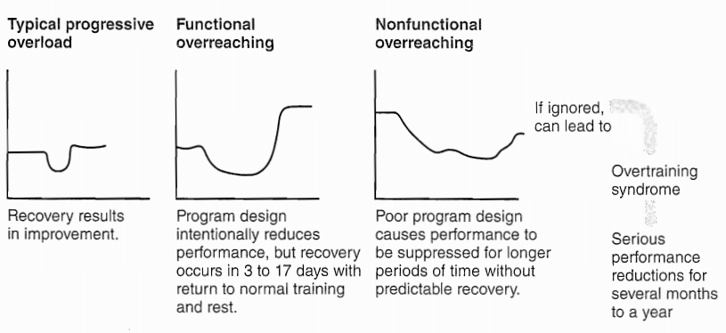
FIGURE 1.5 Functional overreaching results in a temporary drop in performance followed by adaptation and performance gains. If this pattern does not occur, though, it could be a sign of nonfunctional overreaching. Overtime, this could result in overtraining syndrome and a prolonged drop in performance.

Compatibility of Concurrent Training Programs
Once the design of a program is complete, strength and conditioning professionals must consider how to integrate various training goals into the total conditioning program, especially when both resistance training and a high element of cardiorespiratory endurance training are involved.
It has been shown that when athletes perform resistance and cardiorespiratory training simultaneously at high intensity, increases in adaptations to muscle size and power are compromised (8, 25). In addition, some sport coaches use too much aerobic conditioning or think it is necessary to develop an aerobic base. In fact, short-distance sprint-interval programs can be used to accomplish the same goals (9), Soccer (football), basketball, hockey, field hockey, lacrosse, and rugby all have important speed-endurance requirements. However, professionals should not diminish the speed and power components required for many sports by using too much aerobic conditioning training. In contrast, athletes in aerobic endurance sports benefit from heavy resistance training because of the need to strengthen tissues and prevent injury. When done appropriately, it has been shown to positively affect aerobic endurance performance (8, 25).
Another factor that might influence the compatibility of exercise selection is the need to incorporate speed and agility training (S) and sport-specific activities into the training program. Therefore, the judgment on compatibility of training should focus on two issues. First, strength and conditioning professionals should review their analysis on the physiological and biomechanical demands of the sport and the position of the athlete to evaluate the power, strength, and cardiorespiratory endurance demands that must be met. Second, they should determine and monitor with testing what level of detriment, if any, to performance will occur if cardiorespiratory endurance and resistance training are combined within the program. Proper periodization and rest periods are important to recovery and reduce overtraining.

SUMMARY POINTS
Strength and conditioning professionals must carefully evaluate the individual athlete and the sport in order to understand the needs within a resistance training program and the demands of a total conditioning program.
- The essential aspects of a needs analysis for any athlete include the metabolic demands, biomechanical demands, and potential injury risks of the sport.
- Integrating the resistance training program with other conditioning activities is an important aspect for total conditioning. Training goals must be prioritized, training must be periodized, and nonfunctional overreaching and overtraining must be addressed.
- Professionals must be dedicated Io improving the physical development of athletes within the construct of their age, psychological development, physical toleration of training, and proper progression of the program. AS such, a needs analysis is a vital part of the design of any conditioning program, especially the resistance training program (9).

