**2**

**Athlete Testing and Program Evaluation**

**Jay R. Hoffman, PhD, CSCS*D, FNSCA**

**Contents**

Factors That Affect Performance Testing 5

Body Size 5

Fiber Type Composition 6

Training Status 6

Test Selection 8

Specificity and Relevance of the Test 8

Validity and Reliability of the Test 9

Practical Considerations for Test Administration 9

Safety Considerations 9

Timing of Assessment 10

Testing Sequence 11

Interpretation of Test Results 12

Tests for Needs Assessment and Program Evaluation 12

Strength 12

Isokinetic Testing 13

Dynamic Constant Resistance Testing 15

Anaerobic Power and Anaerobic Fitness 17

Laboratory Tests 17

Field Tests 19

Direct Laboratory Measurement 20

Indirect Laboratory Measures 22

Field Tests 24

Speed 26

Agility 26

T Test 27

Edgren Side-Step Test 27

Illinois Test 28

Body Composition 29

Dual-Energy X-Ray Absorptiometry 29

Hydrostatic Weighing 30

Plethysmography 30

Skinfold Measurement 31

Bioelectrical Impedance 33

SUMMARY POINTS 33

The development of strength and conditioning programs is based on scientific evidence gathered through quantitative assessment. In part, the science of coaching involves appropriately interpreting results from assessment programs and filtering this information to the end user (either the athlete or sport coach). A number of justifications for program evaluation exist. It can help strength and conditioning professionals develop athletic performance profiles for specific sports, evaluate the effectiveness of specific training paradigms and athletes' potential for success in a specific sport or position, and set training goals for both teams and individual athletes. This chapter focuses on developing an assessment program, including selecting and administering tests, properly interpreting assessments, and understanding popular laboratory and field tests used to evaluate athletes.

The development of an evidence-based training program is connected to the needs analysis of a sport (see chapter 1). However, to understand the basic physical requirements of a sport, an athletic profile must be developed. The development of this profile requires a detailed battery of testing that provides a thorough analysis of all components comprising athletic performance (i.e., strength, anaerobic power, speed, agility, maximal aerobic capacity and endurance, and body composition), Results from this assessment can determine the relevance and importance of each fitness component for a particular sport. It can also allow appropriate emphasis to be placed on that specific variable in the athlete's training program. A sport-specific athletic profile establishes standards that can be used to predict future success in that sport and to assist in player selection. As discussed previously, both athletes and strength and conditioning professionals can use the sport-specific profile as a motivational tool and to establish training goals by comparing the results, with normative data from similar athletic populations. Performance testing can also be used to provide baseline data for individual exercise prescription, to evaluate the efficacy of specific training programs, and to assist in issues relating to recovery from injury and return to play.

## Factors That Affect Performance Testing

Athlete evaluation needs to be interpreted in relation to a number of factors,

When comparing athletes to one another or when comparing the performance results of a single athlete, the strength and conditioning professional must understand that test results are influenced by several factors. These include body size, muscle-fiber type, the training status of the athlete, and the specificity, relevance, validity, and reliability of the test.

## Body Size

In general, strength is positively related to body size. That is, larger athletes are stronger than smaller athletes. For sports that do not have a weight class, absolute strength is an appropriate way to compare athletes. However, sometimes reporting strength relative to body mass may be more appropriate, especially when comparing athletes of varying mass on strength and power performance.

The issue of body size is also seen in other performance measures. The importance of this can be easily understood when examining vertical jump height and power performance. Two athletes, one weighing 198 pounds (90 kg) and the other 242 pounds (110 kg), are evaluated for lower body power with a vertical jump test. Both athletes jumped 27 inches (68.6 cm). However, which athlete is more powerful? Based on jump height alone, one may assume that both athletes have similar lower body power. However, if power relative to the person’s body mass is examined, then the heavier athlete was much more powerful. The heavier athlete jumped the same distance but with a heavier load. If you recall that power is equal to force × velocity, the greater weight (force) resulted in greater power development. The way the data are examined can result in two substantially different outcomes!

## Fiber Type Composition

The contractile properties of muscles play a significant role in their ability to generate power, sustain performance, and delay fatigue. Athletes with a higher percentage of fast-twitch fibers have the inherent ability to produce greater force and faster contraction velocity (23). In contrast, athletes whose muscles are composed primarily of slow-twitch fibers have a slower rate of fatigue but do not perform as well on strength and power assessments. These athletes will find more success in aerobic endurance sports. Athletes have very little ability to significantly alter their fiber-type composition through training. Therefore, in evaluating athletic speed or agility, it needs to be recognized that athlete’s physiological limitations will influence the extent of their improvement. Although it may be possible to make a slow athlete faster, it is highly unlikely that strength and conditioning professional can make a slow athlete fast.

## Training Status

The training experience of the athlete determines to a great extent the magnitude of potential performance improvements, the greater the training experience, the smaller the potential for achieving performance gains (see figure 2.1). For athletes with limited training experience, the capacity for improvement will be quite high. However, as the duration of training increases, the rate of improvement in performance declines. As training continues further, changes in performance are difficult to achieve, Athletes will appear to have reached a plateau. This plateau may be considered a genetic ceiling, suggesting that performance improvements at this level are limited to the athletes' physiological makeup. Strength and conditioning professionals should also be aware that athletes with a high ability level, regardless of training status, may also be limited in terms of attaining significant performance improvements, even when participating in training programs for the first time (25, 27). Thus, strength and conditioning professionals must understand where their athletes sit on the training curve, and set training goals based on realistic expectations. Recognizing the athlete's experience level is also essential for interpreting performance results. For instance, in a one-year investigation of elite weightlifters, small increases in strength were observed; however, these increases did not reach statistical significance (18). Although they could not see statistical change, practically speaking, the athletes and the strength and conditioning professionals could rate the training program a success, In a group of elite athletes, training improvements are so difficult to achieve that even small improvements can mean the difference between winning and losing. When interpreting test results, especially in an elite athletic population, practical significance should take precedence over statistical significance (24).

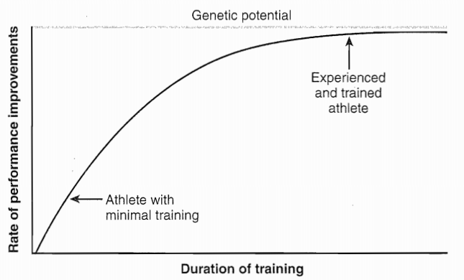

**FIGURE 2.1** Theoretical training curves. Note that as athletes become more and more trained, the speed and degree of improvement in response to training is slower. However, for elite athletes, these small gains may still be significant.

## Test Selection

The selection of a testing battery is generally based on the relevance of each particular fitness component within a particular sport. A typical testing battery may include strength tests for the upper and lower body, power tests, and assessments for speed and agility, cardiorespiratory endurance, body composition, and flexibility.

When developing athletic assessments, the appropriate testing battery is initially determined by the needs analysis of the sport, Once the type of assessments is determined (e.g., strength, power, aerobic endurance, Speed, and so on), the next step is to ensure that the tests selected are reliable, valid, specific, and relevant to the sport being assessed, If any of these concerns are not met, the testing battery would be flawed and would yield very little information.

## Specificity and Relevance of the Test

For a performance test to be of significant value, it is imperative that each test used is specific to the athlete’s training program. For instance, when strength training and testing are performed using a similar mode of exercise (i.e., squats), testing results can accurately reflect the magnitude of strength improvements. However, if training and testing are performed on different training modes (e.g.,, machines versus free weights) or exercises

(e.g.. squats versus leg press), the actual magnitude of strength improvement will not be seen.

A 10-week training study examined two groups of subjects (40). The first group trained on a variable resistance machine (performing leg presses), while the other group trained using free weights (doing squats). The group of subjects that trained with the leg press increased their leg-press strength by 27%, However, when tested on the squatting exercise, the magnitude of their strength improvements was only 7.5%, In contrast, the group that trained with the squatting exercise realized a strength gain of 28.9%, yet their improvement in leg-press strength was only 75%. It appears from this study that strength testing in a mode of exercise that is different from (but uses similar muscle groups to) the one used in training may only reflect 25% of the magnitude of strength gains.

When testing athletes, it is also necessary to select assessments that have relevance to the specific sport. Tests should be selected that provide the athlete and strength and conditioning professional with information concerning the athlete’s ability to succeed in a specific sport. For example, the Wingate anaerobic power test is considered to be the gold standard in laboratory-based power measurements. However, because it is performed on a cycle ergometer, its relevance for sports that do not involve cycling is questionable. As a result, efforts have been made to develop anaerobic power tests that are more specific and have a greater relevance to sports consisting primarily of running or jumping movements (43), an example of a sport-specific anaerobic power test is the vertical jump test. The athlete can perform it on a force plate or while attached to an accelerometer for the sports of basketball and volleyball.

## Validity and Reliability of the Test

One of the most important characteristics of a test is its validity and reliability. Validity refers to the degree that each test measures what it is intended to or claims to measure. For example, the 1RM squat exercise is considered a valid measure of lower body strength, primarily because it recruits the greatest muscle mass in the lower body. Reliability refers to the ability of each test to produce consistent and repeatable results, Tests selected that have proven reliability can reflect even slight changes in performance when evaluating a conditioning program. If a test is unreliable, then differences in testing may reflect only the variation of the test, not the effectiveness of the training program.

## Practical Considerations for Test Administration

To attain accurate assessments, tests need to be administered safely and in an organized fashion. Assessment timing should be carefully planned, and the tests should be administered in a proper sequence. In addition, all athletes being tested should have a clear understanding of the purpose of each test.

## Safety Considerations

All athletes, regardless of level of competition, should be medically cleared before participating in any health or performance assessment, the goal of attaining medical clearance is to determine whether athletes have any contraindication to participation in either an exercise program or a fitness assessment. It is the responsibility of each strength and conditioning professional to ensure that medical clearance has been obtained. It is highly for standard operating procedures. The procedure manual should be completed with the assistance of the team physician or sports medicine team associated with the facility.

## Timing of Assessment

To maximize the information provided by assessment programs, it is imperative that evaluation periods are conducted throughout the training year; the goal of each evaluation period may be different, focusing on determining training goals, assessing the effectiveness of the training program, or evaluating the readiness of athletes to compete.

To evaluate the effectiveness of a training program, assessments should be performed at its onset and conclusion, to assess the physical readiness of the athletes to participate in a competitive season, testing should occur at the onset of training camp. Novice athletes who are being evaluated prior to beginning a fitness program should be allowed sufficient time to learn how to perform each of the tests. This will allow the athletes to perform each of the tests safely, resulting in more accurate assessments and more effective exercise prescription.

Figure 2.2 shows examples of specific testing periods throughout a training year. This testing schedule is for collegiate American football players, with a competitive season lasting from September to November. The first testing session should be held before off-season (winter) work-outs begin in order to guide exercise prescription, establish training goals, and serve as a motivational tool for the athletes. The second round of testing should occur at the end of winter workouts and before summer workouts begin, about three months before the start of the competitive season. This testing session helps strength and conditioning professionals evaluate the winter conditioning program, check the athletes' progress, and continue to motivate them. The final testing session, at the very start of training camp, serves as a final evaluation of the effectiveness of the summer training program.

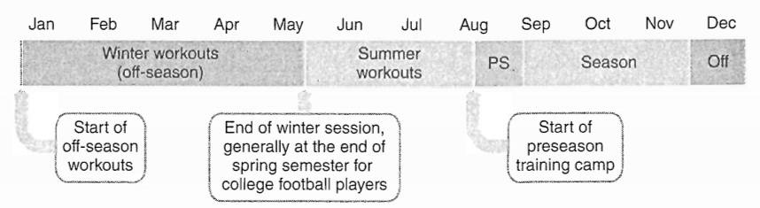

**FIGURE 2.2** Timing of athlete assessments for a collegiate American football team.

## Testing Sequence

One of the most important administrative concerns is the order in which the testing battery is performed. In general, the least fatiguing tests should be performed first. Tests that require high-skill movements, such as agility measurements, should be performed prior to any fatiguing tests. Any performance test that fatigues the athlete will confound the results of any subsequent tests. For example, aerobic endurance exercise preceding strength training appears to cause a significant decrease in strength expression (33). However, no detrimental effects on aerobic endurance performance have been noted when strength testing is performed first. Thus, it would be prudent for athletes to perform the more fatiguing tests (e.g., 300-yard shuttle runs, line drills, 1, 5-mile run) last during a testing battery.

Many factors influence testing sequence, including the number of athletes being tested, the length of the testing period (e.g., 2 hours, one day), and the number of strength and conditioning professionals available to assist. In an ideal testing scenario, all athletes would perform the testing in the same sequence. If testing is performed over an extended time period (e.g., over two days), the most fatiguing tests should be performed last, However, due to time constraints, the ideal testing sequence may not always be realistic.

Testing a team or other large group of athletes may require simultaneous use of several different testing stations. Athletes often rotate through various stations within a set time period. Some athletes may perform a 40-yard sprint, followed by strength measures. Other athletes perform their strength tests before sprint and agility tests.

A testing scenario likely to yield accurate results includes the performance of endurance and shuttle runs (the most fatiguing tests) at the end of the testing battery and the provision of proper rest, which involves at least 5 minutes between stations for the phosphagen energy system to be restored (20). Strength and conditioning professionals should also consider how muscle potentiation may be affected by test sequence, performing maximal squat testing first may significantly enhance vertical jump height (28).

## Interpretation of Test Results

Once testing is completed, the information obtained must be communicated to both the athlete, and when appropriate, to the sports coach. Individual results can be compared to previous results to evaluate progress in the team’s conditioning program. Performance results can also be compared with those of other athletes playing in the same sport and position to assess the athlete’s potential. Results can also be used to prescribe exercises, develop training goals, and motivate athletes.

## Tests for Needs Assessment and Program Evaluation

The remainder of this chapter discusses tests that are common to each of the performance variables. It is not meant to be an all-inclusive list of potential tests. However, the discussion focuses on tests that are widely accepted and used.

## Strength

When assessing strength, strength and conditioning professionals must decide which type of exercise to use and whether to test maximal strength or predict it from submaximal assessment. In regard to test selection, they must remember the importance of specificity. The test should be part of the athlete's resistance training program. As mentioned previously, this allows a clear understanding of the effectiveness of the conditioning program and provides a true measure of the athlete’s ability. If initial testing occurs prior to the onset of a conditioning program (for example, freshman athletes being tested on the first day of practice), the exercises used to assess strength may be novel to the athletes. These tests would be appropriate as long as the exercises are part of the resistance training program that follows, the same tests are used to reassess the athletes at the conclusion of the training program, and the tests are not too technically demanding (e.g.,, 1RM cleans). Another benefit of using an exercise that is part of the athlete’s conditioning program is to ensure proper technique, thereby reducing the potential for injury during testing and to provide appropriate selection of the resistance attempted during the strength test.

Strength testing can be performed with dynamic, constant-resistance exercises (i.e., free weights), isokinetic testing, or an isometric dynamometer. The mode of exercise used to assess strength depends on the goals of the testing program. If strength tests are part of an evaluation to predict potential sports performance, they should incorporate similar movement patterns and involve the same muscle mass that is routinely recruited during actual sport performance. Strength testing should involve exercises that engage multiple joints and large muscle mass.

Generally, strength tests are used to provide a measure of strength for a certain area of the body (e.g., upper body or lower body), Thus, tests should be selected that are common to the athlete’s training program and that recruit the largest amount of muscle mass for a particular body area. In general, the bench press exercise is commonly used to assess strength in the upper body and the squat exercise is commonly used to assess strength in the lower body. Both of these tests recruit a great amount of muscle mass.

## Isokinetic Testing

In some cases, an exercise that recruits a smaller muscle mass or an isolated joint action may provide additional information, For example, comparing muscle groups from bilateral limbs (i.e., right-knee flexors with left-knee flexors) or agonist versus antagonist muscle groups (i.e., knee flexors versus knee extensors) may indicate a potential Weakness that can predispose the athlete to injury, Isokinetic testing isolates these muscle groups in order to make these important comparisons. Isokinetic testing devices (see figure 2.3) measure joint movements at a constant velocity. The force exerted by a moving body segment is met with an equal and opposite resistance that is constantly altered as the body segment moves through its full range of motion. The force exerted by the body segment to produce rotation around its axis is referred to as torque, and is expressed in Newton-meters (N < m).

Since isokinetic devices only permit the evaluation of a single-joint, unilateral movement, their role in strength evaluation is primarily limited to determining the athlete’s potential for muscle injury as a result of either a bilateral deficit or a muscle-joint imbalance (24). This mode of testing is also time consuming. Therefore, it is typically used by athletic trainers who Work individually with rehabilitating athletes.

Research that evaluates antagonistic-to-agonist strength ratios and their ability to predict injury is equivocal (23). The primary issue is the large variability seen among athletes of different sports, the effect of resistance training on strength improvements in specific muscle groups, and the differences seen in antagonistic-agonistic ratios between different joints. The examination of bilateral strength differences appears to be a bit more promising in regard to predicting risk for injury. Bilateral strength deficits of 15% or greater may indicate a significant risk for injury (32). For athletes with strength imbalances greater than 15%, an incidence of muscle injury has been reported that is 2.6 times greater (32). However, much debate still exists about the effectiveness of the use of bilateral deficits.

In some athletes in sports that rely predominantly on unilateral arm action (e.g.,, tennis, baseball pitching), bilateral deficits are often noticed in the muscle groups of the shoulder, elbow, and wrist (9, 13), Strength differences approaching 20% in the upper limb have been seen in tennis athletes and baseball pitchers, These large bilateral-strength differences may be compounded by the non-weight-bearing requirements of the upper body musculature. It is still not fully understood whether this large bilateral strength difference negatively affects performance or increases the risk for injury in these athletes.

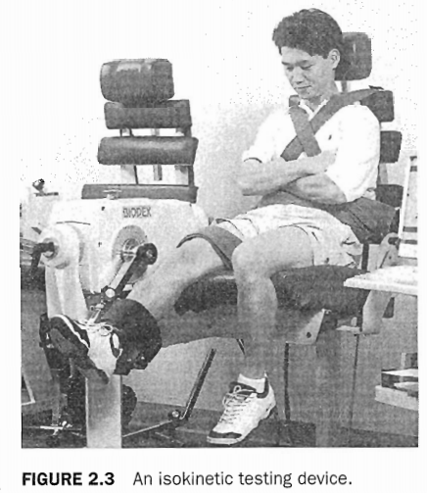

## Dynamic Constant Resistance Testing

The use of dynamic constant resistance exercises, performed with free weights, is the most popular mode of strength testing, this is related to several factors, including the likelihood that the exercises used for testing are also part of the athlete's training program, the exercises selected can better simulate actual sport movement, and the large muscle mass that these exercises generally recruit. The issue that is frequently encountered in testing maximal strength is whether to directly measure one-repetition maximum (1RM) or to predict maximal strength from the number of repetitions performed with a submaximal load. Often, the decision is based on practicality. When testing large groups of athletes (as is often the case when strength testing a team), time is an important and valid consideration.

Another issue that has been raised with maximal strength testing is the potential risk for injury. It is important to note that absolutely no research supports this contention. As long as the athlete is using appropriate loads, a qualified strength and conditioning professional is present, spotters are used properly, and the equipment and testing area is safe, the use of 1RM testing does not increase the risk for injury, The bench press, squat, and the power clean are Widely used measures to assess upper body strength, lower body strength, and explosive power, respectively. These tests have been demonstrated to have strong test-retest reliability (V > 0.90) (24), A protocol for assessing a lRM is presented in the sidebar on the next page.

The validity of submaximal tests to predict maximal strength has previously been demonstrated (correlation coefficients >0.90) (33, 36, 37). It should be noted that the number of repetitions performed at selected percentages of the 1RM is quite variable among exercises, and that the variance within an exercise is also quite large (22). Table 2.1 provides examples of published formulas that can be used to predict a 1RM.

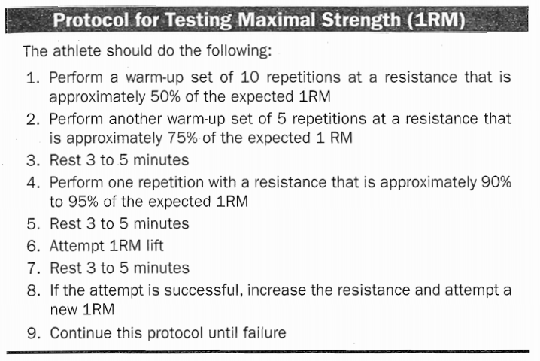

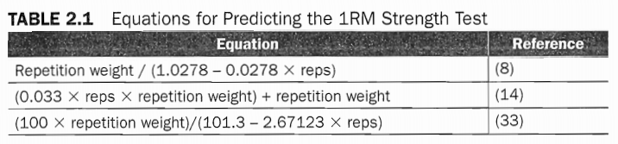

Another concern is the number of repetitions that are performed to predict maximal strength. When a submaximal bench-press test is used to assess maximal upper body strength, the validation of the prediction model is maintained as long as the number of repetitions performed is 10 or fewer. If more than 10 repetitions are performed, the equations lose their validity and tend to underestimate actual strength levels (37). Thus, if strength and conditioning professional decides to use a submaximal test to predict maximal strength, it is recommended that the loading be relative to the strength level of the athlete. For example, some American football teams use loads specific to the player's position. For instance, linemen perform as many bench press repetitions as possible with 330 pounds |150 kg). line backers perform as many repetitions with 300 pounds (136 kg), and so on, This time-efficient method gives athletes a better opportunity to produce a valid test.

## Anaerobic Power and Anaerobic Fitness

Anaerobic power can be assessed in both laboratory and field settings. For most strength and conditioning professionals, the ability to work with a human performance laboratory is limited. However, if the opportunity presents itself, a human performance laboratory allows for greater sophistication and sensitivity in athletic assessment, this section discusses tests for both the laboratory and the field that can be used to assess anaerobic power and fitness. Anaerobic power provides information about an athlete’s potential, whereas anaerobic fitness describes the athlete’s ability to perform high-intensity exercise for a prolonged duration of time (e.g., a game). For example, seeing how high a basketball player can jump provides information to help determine his potential. However, it does not provide any information as to whether the athlete's physical condition is good enough for playing basketball.

## Laboratory Tests

A variety of laboratory tests can be used to assess anaerobic power. These tests differ in the mode of exercise, sensitivity of the assessment, and the extent of information provided. Anaerobic power can be evaluated through sprints on a nonmotorized treadmill (14, 43), repeated jumps on a force plate or contact mat (7), and maximal-effort cycling tests (3, 31, and 44). These tests assess peak power (highest power output attained during the test), mean power (average power output of entire test), or both, additionally, fatigue rate (the athlete's ability to maintain power output throughout the duration of the test) may be reported,

The gold standard for laboratory-based anaerobic power tests is the Wingate anaerobic power test (WAnT) (5). This 30-second maximal-effort cycling test is performed against a resistance relative to the subject's body weight. The WAnT was first developed at the Wingate Institute in Israel. Of all the laboratory-based anaerobic power tests available, the WAnT has the most extensive research base to date. Test-retest reliability has consistently been shown to exceed r > 0.90 (5).

The WAnT provides assessments of an athlete's peak power and mean power, as well as a fatigue index. However, as the sophistication of computer programs evolved, many human performance laboratories have begun to vary the duration of the test. Some have used repeated trials of shorter duration (10-20 s), or have performed a longer, 60-second test (26, 29). Although it is not clear whether the fatigue index is a good indicator of anaerobic fitness, the index does appear to correlate highly with the percent of fast-twitch fibers (6). Typically, a greater fatigue index is seen in athletes with a greater percentage of fast-twitch fibers. Athletes who are trained for aerobic endurance generally have a lower fatigue index. Figure 2.4 depicts a sample performance diagram produced from a 30-second WAnT.

The primary drawback of WAnT and the reason that it has not achieved widespread acceptance among strength and conditioning professionals, is related to questions concerning specificity of muscle and activity patterns. Few sports are performed using motions similar to those on a cycle ergometer. Anaerobic power assessment of a basketball player, for instance, may be more specific if performed with a vertical-jump power test, this test requires the athlete to perform repeated countermovement jumps on a force plate or contact mat. The flight time of each jump is recorded (from the moment subject breaks contact with the mat until he or she makes contact when landing), The time in flight is used to calculate the change in the b0dy's center of gravity (7). Using body weight and the calculated jump height, mechanical work is calculated. Anaerobic power can be determined by using both mechanical work and the length of contact time between jumps. A vertical jump anaerobic power test does have greater sport specificity, especially for basketball and volleyball (24).

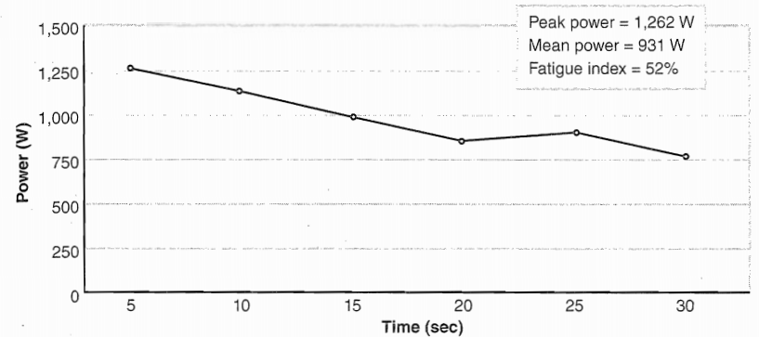

**FIGURE 2.4** Example of power output over the course of 30 seconds in a Wingate anaerobic power test (WAnT).

## Field Tests

When testing large groups of athletes, several administrative concerns (Equipment availability and the fact that only a single subject can be tested at any one time) may preclude use of any of the previously mentioned tests. As a result, most strength and conditioning professionals use a field-based test to provide similar assessments to those obtained from laboratory-based measures. The vertical jump is a popular field test for anaerobic power. A few field tests can be used to evaluate anaerobic fitness. 'Iwo of the most popular is discussed in the following section.

**Vertical Jump** The vertical jump is perhaps the most popular field test for assessing anaerobic power. It is relatively easy to perform and provides a specific measure of power for athletes participating in sports that involve jumping. The primary drawback of the vertical jump test is that it can only measure jumping height. To provide a more accurate assessment of power, a formula can be used to estimate power output from the vertical jump test (19). Keep in mind that power outputs are recorded in Watts (W). The equations to calculate peak and mean power are as follows:

Peak power (W) = 61.9 × jump height (cm) + 36 × body mass (kg) + 1.822

Mean power (W) = 21.2 × jump height (cm) + 23 × body mass (kg) − 1.393

**300-Yard Shuttle Run** The shuttle run is a field test often used to assess anaerobic capacity. Following an adequate warm-up, the athlete lines up at the starting point, At the signal, the athlete sprints to a point 25 yards (23 m) away and then returns to the starting line, A total of six round trips are performed (12 × 25 yards = 300 yards, or 273 m), As the athlete crosses the line on the final sprint, the time is recorded to the nearest 0.1 second, and a 5-minute rest interval is begun. Following the S-minute rest interval, the athlete repeats the 300-yard shuttle. The average of the two times is recorded.

**Line Drill** The line drill is a field test used to measure anaerobic fitness in athletes. The line drill can be performed on a regulation-size basketball court or in any outdoor or indoor facility with similar space dimensions (see figure 25), The athlete begins from a standing position and Sprints from the baseline to four separate cones placed at the near foul line (5.8 m), half-court line (14.3 m), far foul line (22.9 ml, and far base- line (28.7 m). As athlete arrives at each cone, he Sprints back to the original starting point and proceeds as rapidly as possible to next cone. When performing this test in an outdoor facility such as a football field, yard line markers can be used. For instance, when testing football players, the goal line would be the starting point and cones would be placed at the 10-, 20-, 30-, and 40-yard lines (9, 18. 27, 36 m). The procedure would then be the same as if performed indoors. When testing a large group of subjects, athletes should touch the lines instead of touching the cones. In order to accurately assess each athlete, strength and conditioning professional with a stopwatch must be present for each athlete who is running. A total of three trials are often used, with a 2-minute rest period between each trial. All sprint times are recorded 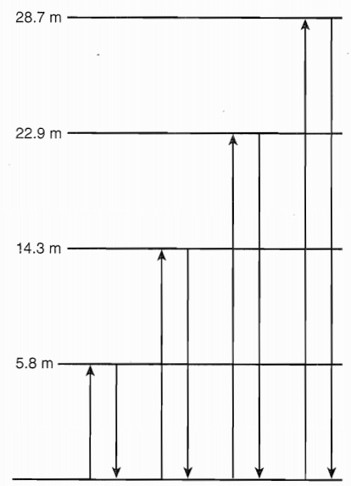and the fastest time is reported. A fatigue index is generated by dividing the fastest score by the slowest score.

## Aerobic Capacity and Aerobic Endurance

Success for athletes in aerobic endurance sports, such as cross-country skiing, running, swimming, and cycling, often depends on a large aerobic capacity. Although many factors determine aerobic performance (i.e., capillary density, mitochondrial number, muscle-fiber type), the V02maX of the athlete provides important information concerning the capacity of the aerobic energy system. Maximal aerobic capacity can be either determined by directly measuring oxygen consumption (VOX) while exercising to exhaustion or predicted through submaximal exercise tests**. Figure 2.5** sprinting pattern

## Direct Laboratory Measurement

The most common laboratory method for assessing aerobic capacity is directly measuring oxygen consumption while an athlete performs a graded exercise test on a treadmill to exhaustion. Maximal aerobic capacity can also be determined while an athlete performs on a cycle ergometer, during tethered swimming, or while swimming in a swimming flume, the choice of exercise should be determined by the athletes sport.

Aerobic capacity measured on a treadmill will produce the greatest results, In a study of triathletes, the VO2max from tethered swimming and cycle ergometry were 13% to 18% and 3% to 6% lower, respectively, than values obtained from treadmill running (38).

Figures 2.611 and 2,6b describe popular treadmill-testing protocols for assessing maximal aerobic capacity for the general population. Many protocols have been developed, and some are population specific. For instance, some exercise protocols are designed primarily for cardiac rehabilitation, while others are primarily designed for athletes. The primary differences between the two are the initial starting points (elevation and speed of the treadmill) and the increments for each stage of exercise (increases in elevation and speed). For an athletic population, the exercise protocol for may require the subject to begin exercising at a self-selected speed between 134 and 188 m/min. The athlete should maintain the self-selected speed for the duration of the test, while the treadmill elevation will increase by 2% every 2 minutes until the athlete reaches exhaustion.

Prior to the onset of a maximal exercise test, the subject should be allowed to warm up for at least 5 minutes or until he or she feels ready to proceed. Generally, the warm-up is performed at 0% grade on a treadmill, at a speed that the subject considers comfortable. Following the warm-up, the subject is attached to the breathing apparatus, and the testing protocol begins. The test ends when the subject indicates that he or she has reached exhaustion or when subject has met three of these four criteria to ascertain that VO2max has been reached:

1. The increase in oxygen uptake is no greater than 150 ml/min, despite an increase in exercise intensity (plateau criterion)

2. Attainment of age-predicted maximal heart rate (HRmax)

3. A respiratory exchange ratio (VCO2/VO2) greater than 1.10

4. A plasma-lactate concentration ofa1leas18 mmol/L Within 4 minutes of ending exercise

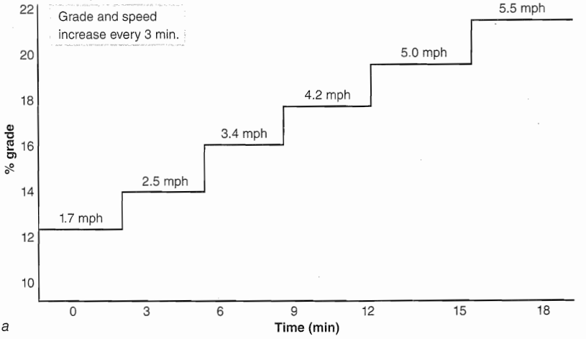

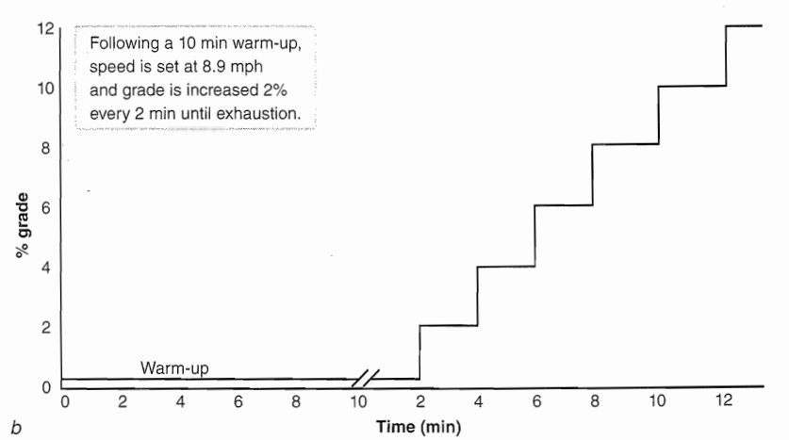

**FIGURE 2.6** Two treadmill protocols for assessing maximal aerobic capacity: (a) Bruce Treadmill Protocol for Assessing Maximal Oxygen Consumption, (b) Costill and Fox Treadmill Protocol for Assessing Maximal Oxygen.

## Indirect Laboratory Measures

Considering the costs that are associated with the equipment, space, and personnel needed to directly measure oxygen consumption, this methodology of testing is generally reserved for research or clinical settings, when direct measurement of VO2max is not possible, a variety of submaximal tests are available to predict aerobic capacity, The validity of these tests has been well established. They are based on several assumptions, including that a steady- state heart rate is obtained for each stage of exercise, a linear relationship exists between heart rate and the intensity of exercise, the maximal heart rate for a given age is consistent, and the efficiency of exercise (i.e., VO; for the intensity of exercise) is the same for everyone. If any of these assumptions are not met, the validity of the test may be reduced. These tests are generally performed in a controlled environment; they are administered on an individual basis. Submaximal aerobic testing can be performed on either a cycle ergometer or a treadmill. Generally, a submaximal test uses an endpoint of 85% of age-predicted maximal heart rate. A treadmill protocol for submaximal aerobic testing is shown in figure 2,7, If using a treadmill, the speed and grade of the final stage can be used to estimate VO2max. The following formula may be appropriate to use (11):

VO2max (ml.kg-1 .min-1) = 15.1 + (21.8 × speed in mph)-(0,327 × heart rate)

- (0263 × speed in mph × age) + (0.00504 × heart rate × age) + (5.98 × gender)

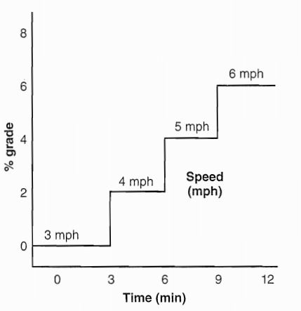

**FIGURE 2.7** A testing progression for submaximal aerobic testing on a treadmill. Each Stage should be maintained for 3 minutes to allow a steady-state heart rate to be achieved.

For gender, insert 0 for females and 1 for males. This formula is reported to predict VO2max within 4.85 ml.kg-1 .min-1of actual VO2max.

The benefit of using a treadmill is primarily related to the fact that most people are more familiar with either walking or running as compared to riding a cycle ergometer, however, cycle ergometers may still be a more popular mode of testing because they make it easy to perform other measures (i.e., blood pressure and ECG readings) during the test. The test is also non-weight-bearing in nature. In addition, cycle ergometers are relatively inexpensive compared with treadmills, they are also safer (e.g., the chance of a subject tripping or falling while cycling is lower than that of running on a treadmill). All these reasons may contribute to a greater use of sub-maximal cycle-ergometer testing.

For the YMCA submaximal cycle-ergometer test, the initial workload is set at 150 kg. m. min-1 (05 kp), Each stage is 3 minutes in duration. The work load at each subsequent stage varies depending on the heart rate in the last minute of the previous stage (see figure 2811). The heart rate measured during the last minute in each stage is then plotted against work rate. The line generated from the plotted points is extrapolated to the athlete's age-predicted maximal heart rate. A perpendicular line is dropped to the x axis to determine the work rate that would have been achieved it the athlete had worked to maximum (figure 2.8b), VO1max can then be calculated with the following formula:

VO2max (ml/min) : workload (kg .m .min-1) × (2 ml.kg-1 .min-1)+ (3.5 ml.kg-1 .min-1) × body mass (kg)

## Field Tests

When testing large groups of athletes, it may be more feasible to administer a field test to estimate aerobic capacity. These tests include measuring the time to run a given distance or the distance that can be run in 12 minutes, the most popular tests are the Cooper 12-minute run and the 1.5-mile test for time (1). The goal of the Cooper test is for the athlete to run as far as possible in the 12-minute time period. To estimate the athletes’ VO2max for the 12-minute run, the following formula can be used:

VO2max (ml.kg-1.min-1) = (0.0268 × distance covered in meters) – 11.3

The distance for a single lap for most oval tracks is 400 m. For instance, if an athlete ran six laps, he has run 2,400 m. using the formula, the estimated VO2max for that athlete would be 53.0 ml.kg-1 .min-1 [(0.0268 × 2.400) -11.3]. The primary drawback for this test is that it may be quite difficult to estimate distance run, especially if the athlete did not complete a set fraction of a lap. Administratively, it may be easier to have athletes run a given distance. This allows a single administrator to call out the times of each runner as he complexes the six laps.

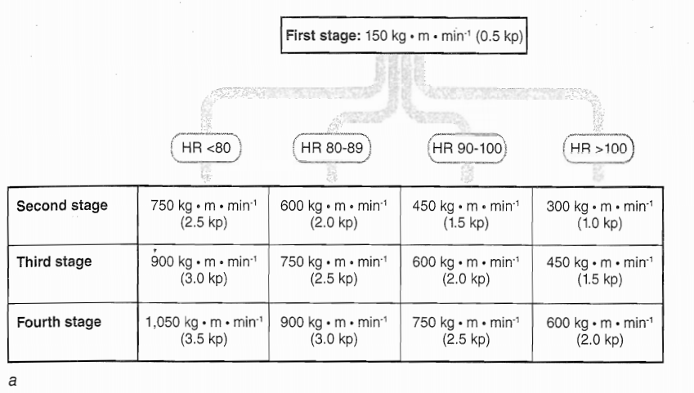

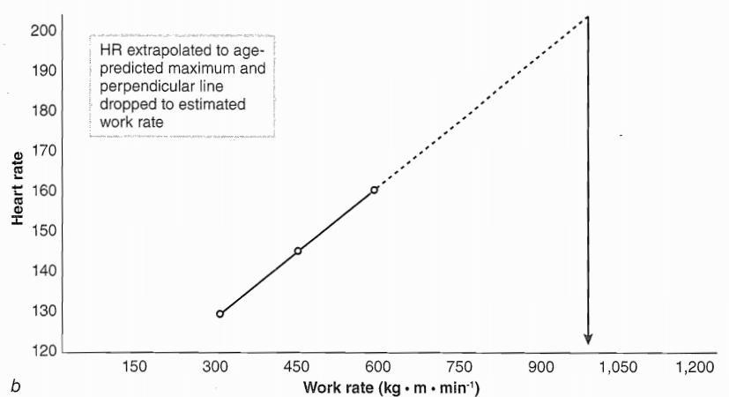

**FIGURE 2.8** (a) Workloads, based on heart rate, for stages 2 through 4 of the YMCA Submaximal cycle-ergometer test. (b) The line graphed from the heart rates measured in the last minute of each stage can be extended to the age-predicted maximal heart rate to estimate maximal work rate.

Aerobic capacity can be estimated for the 1.5-mile run by the following formula:

VO2max (ml.kg-1 .min-1) = 3.5 + (483 + time in minutes to run 1.5 miles)

If an athlete ran 1.5 miles in 11.0 minutes, the VO2max would be calculated as 47.4 ml.kg-1 .min-1 [35 + (453/11.0)].

## Speed

Speed is the ability to perform a movement in as little time as possible. It is relatively easy to measure, requiring only the use of a stopwatch and track or field area. For programs with larger training budgets, electronic timers are becoming more popular. The major issue with using a stopwatch is the potential for measurement error. Even under ideal conditions with an experienced tester, stopwatch times may be 0.2 seconds faster than electronically measured times because of the tester's reaction-time delay in pressing the stopwatch's start and stop buttons as the athlete begins and ends the sprint (24).

The 40-yard sprint is the most popular distance used in most speed assessments, This is probably due to the familiarity that most strength and conditioning professionals have with sprint times associated with this distance. The 40-yard sprint has achieved tremendous popularity among American football coaches. It is a staple of most football testing programs. Considering the large player rosters and the number of strength and conditioning professionals who have a football background, the 40-yard sprint has become a staple for most athletic testing programs in the United States. However, the justification for the 40-yard distance is not entirely clear. It may have originated as an arbitrary distance that has become well accepted over time.

Other sports have used either shorter or longer distances, depending on the specific needs of the sport. Some strength and conditioning professionals for basketball use a 30-yard sprint (the approximate length of a basketball court) to assess speed. Baseball, on the other hand, often uses the 60-yard sprint (the distance between three bases, such as home to second or first to third).

## Agility

Agility refers to the ability to change direction rapidly. It is a common variable measured during most athletic performance testing. Like speed, it is relatively easy to measure. All that is needed is a stopwatch and Cones. A variety of different agility tests can be selected. However, the most relevant agility performance test is one that incorporates movements that are similar to those performed by the athlete during competition. The test used should also be part of the athlete's training program.

For example, movement patterns in basketball involve sprints, side shuffles and backward runs. The T test is an agility measure that utilizes those specific movement patterns. It is very appropriate for assessing agility in basketball players. Popular agility tests include the T test, Edgren side- step test, the pro-agility (5-10-5) test, and the Illinois test.

## T Test

For the T test, arrange four cones as seen in figure 2.9. Cones A and B are 10 yards (9 m) apart. Cones C and D are placed 5 yards (4.5 m) from either side of cone B. Following a warm-up, the athlete begins by standing at cone A At the go command, the athlete does the following:

Sprints to Cone B and touches the base of the cone with the hand sidesteps either to the left to cone C or to the right toward cone D and touches the base with the closest hand 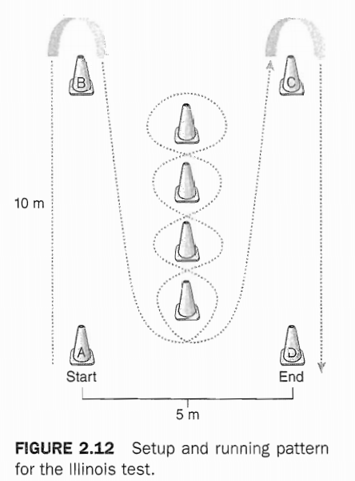Sidesteps to the other far cone (C or D) and touches the base of the cone with the closest hand (The athlete does not touch cone B as he crosses to the other cone.) Sidesteps back to cone B and touches the base of the Cone Runs backward to cone A (The time is stopped when the athlete crosses the cone)

The athlete should face forward at all times and should not cross the feet. Crossing the feet or failing to touch a cone results in disqualification.

## Edgren Side-Step Test

For the Edgren side-step test, a 12»foot-vvide (4 m) gymnasium floor is divided into four 3-foot (1 m) sections using five lines (see figure 2.10). After a warm-up, the athlete straddles the center line, On the go command, the athlete does the following:

1. Sidesteps to the right until the right foot has touched or crossed the right outside line
2. Sidesteps to the left until the left foot has touched or crossed the left outside line
3. Continues to sidestep back and forth to the outside lines as rapidly as possible for 10 seconds

The total number of lines crossed, including the outermost lines, for the 10 seconds is recorded. A point will be deducted from the total score any time that the athlete crosses the feet.

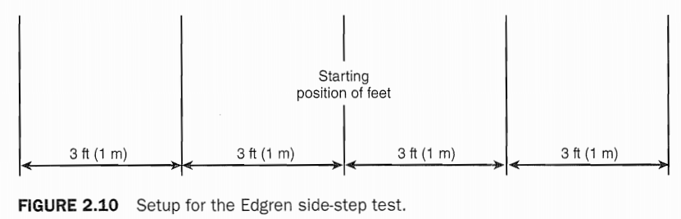

## Illinois Test

Eight markers are required to set up this test; four of the markers are used to form a rectangle 10 m long by 5 m wide. The other four are placed in a straight line in the center of the rectangle at 3.3 m intervals. This test requires the athlete to begin by lying face down at marker A.

When given the go command, the athlete sprints forward 10 m to marker B, performs a U-turn, and sprints back in the opposite direction. When approaching the starting position, the athlete veers diagonally to the left, and enters an agility course consisting of four markers in the center of the rectangle. The athlete runs in a zigzag, weaving around the obstacles. When he reaches the end of the course, the athlete turns around and performs the same pattern bark to the starting position. After weaving through the last marker, the athlete makes a U-turn to the left and sprints toward marker C, then makes a final U-turn and sprints straight ahead to marker D (see figure 2.12).

## Body Composition

Body Composition generally reports the percentage of body weight that is fat. The range in body-fat percentages varies among different athletes. This is related primarily to the specific demands of each Sport, Aerobic endurance athletes or gymnasts are generally on the very lean side, but some American football players (primarily linemen) may be borderline obese. A number of methods can be used to assess body composition. These methods vary in terms of complexity, cost, and accuracy; the following sections briefly describe their methods.

## Dual-Energy X-Ray Absorptiometry

Dual-energy X-ray absorptiometry (DEXA) has become the new gold standard of body-composition assessment. It is a noninvasive procedure that provides regional and total body measurements of lean and tat tissue, bone density, and bone mineral content. The reliability and validity of DEXA for body-composition assessment has been established at low, moderate, and high levels of body fat and with athletic and nonathletic populations (16,45), One of the major advantages of DEXA measurements is that it uses a three-compartment model (fat mass, lean tissue mass, and bone density) to determine body composition. Such a method is superior to the more common two-compartment model (fat and lean tissue mass). It appears to result in a more accurate measurement of body composition, eliminating additional sources of error seen during estimation of body density (e.g., residual volume). The major drawback to DEXA measurements is the cost of purchasing and operating the machine. In addition, because the DEXA is an X-ray device, the radiological boards in some states require physician prescription and operation by a licensed X-ray technician. These requirements make body-composition testing through this technique unrealistic for most assessment facilities.

## Hydrostatic Weighing

For years, hydrostatic weighing was considered to be the gold standard of body-composition analysis. Hydrostatic Weighing measures body composition based on the amount of water that is displaced when an athlete is submerged. As the body is immersed under Water, it is buoyed by a counterforce equal to the weight of the water displaced. The loss of weight in water, corrected by the density of Water, allows body density to be calculated. Once body density is calculated, then the body-fat percentage can be calculated through various equations that depend on age, growth and maturation, gender, and ethnicity.

In addition, calculation of lung residual volume is needed to accurately assess body density. This can be either measured directly or predicted through various formulas. Although this method of” body composition is highly reproducible, several factors that may reduce the accuracy of measurement still remain. For instance, the accurate measure of residual volume is important to reduce error, It may not account for possible air in the intestines. Calculation of body density also makes several assumptions that may increase the error in atypical populations. It is generally assumed that body-composition analysis using the hydrostatic method provides an estimation of body fat within 2.5% of the true value (17).

## Plethysmography

Plethysmography is a viable method of assessing body composition, especially for athletes who are uncomfortable being fully immersed in the hydrostatic tank. The use of an air displacement Plethysmography (closed chamber that measures body volume by changes in pressure) has been found to be highly reliable in a number of subject populations (2, 10). Air-displacement Plethysmography has been shown to be a valid measure of body composition (4, 38, and 41). However, it may overestimate body-fat percentage in comparison to DEXA (37, 40). Although the use of air displacement provides an accurate assessment of body-fat percentage, the calculation may be higher than that seen from DEXA measures. Thus, comparisons between these modalities may be difficult to perform.

## Skinfold Measurement

Skinfold measurement is the most popular method used to assess body composition. They take significantly less time to complete than the other modalities discussed. The principle behind Skinfold measurement is that the amount of subcutaneous fat is proportional to the amount of body fat. By measuring Skinfold thickness at various sites on the body, body-fat percentage can be calculated through a regression equation. Commonly used Skinfold sites include the following:

* Abdomen: Horizontal fold, 2 cm to the right of the umbilicus
* Biceps: Vertical fold on the anterior aspect of the arm over the belly of the biceps muscle
* Chest: Diagonal fold, one-half of the distance between the anterior axillary line and the nipple (men), or one-third of the distance between the anterior axillary line and the nipple (women)
* Midaxillary: Horizontal fold on the midaxillary line at the level of the xiphoid process of [he sternum
* Subscapular: Diagonal fold at a 45° angle, 1 to 2 cm below the inferior angle of the scapula
* Suprailiac: Diagonal fold in line with the natural angle of the iliac crest taken in the anterior axillary line
* Thigh: Vertical fold on the anterior midline of the thigh midway between the proximal border of the patella and the inguinal crease
* Triceps: Vertical fold on the posterior midline of the upper arm midway between the acromion process of the scapula and the inferior part of the olecranon process of the elbow

However, because the ratio between subcutaneous fat and total body fat varies according to age, gender, and ethnicity (35), the appropriate regression equation must be selected. In addition, regression equations also vary in the needed number of Skinfold site. Even when the appropriate regression equation is used, a 3% to 4% error may be associated with the body-fat percentage attained from Skinfold measurements (35), thus, care must be taken in selecting the correct regression equation. Table 2.2 provides several examples of commonly used regression equations; Table 2.3 provides population-specific equations for converting body density to body-fat percentage.

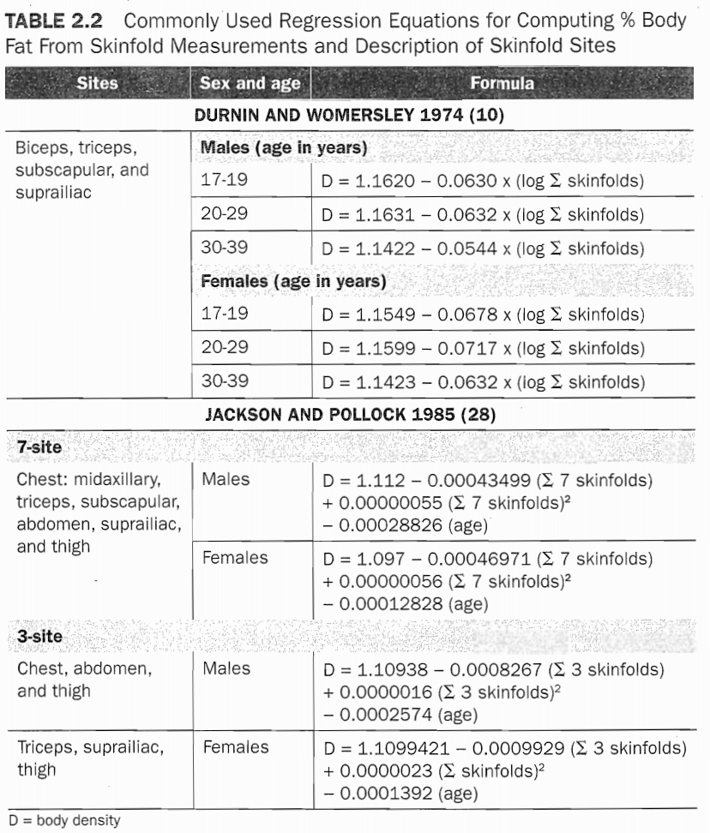

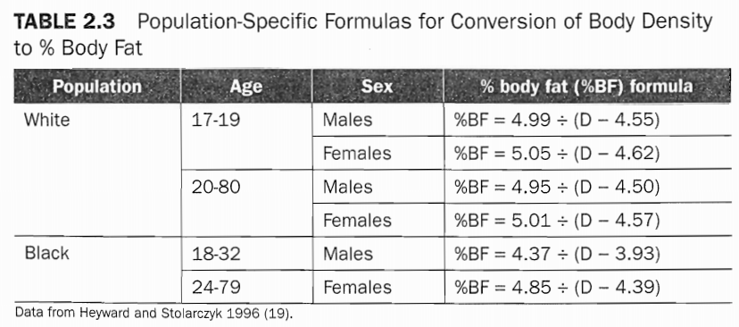

## Bioelectrical Impedance

Bioelectrical impedance is another popular modality used to estimate body composition. It is similar to Skinfold measure in regard to accuracy, and it may be easier to use because it eliminates potential error among testers. The basic principle behind bioelectrical impedance is the relationship between total body water and lean body mass. Since lean tissue contains a large concentration of water, and water is an excellent conductor of electricity, the resistance to an electrical current passing through the body provides a potential indicator of body-fat percentage. Lean athletes would have minimal resistance, indicating that a higher percentage of lean tissue is present. A higher resistance to the electrical current would suggest a greater amount of body fat.

Because body water content is critical to these measures, any change in body fluid can have a significant effect on body-fat calculation, If bioelectrical impedance is to be used, it is highly recommended that subjects refrain from drinking or eating within four hours of the measurement, void completely prior to the measurement, and refrain from ingesting any alcohol, caffeine, or any diuretic agent prior to assessment (23). Failure to comply will increase measurement error, Performing this measurement when dehydrated may overestimate the body-fat percentage (less body water leads to fewer conductances).

## SUMMARY POINTS

* An assessment program can be used to examine the effectiveness of training programs, evaluate athlete potential. Develop training programs, and set training goals.
* To maximize the effectiveness of the assessment program, the tests must be reliable and valid, and must provide relevant information to both the strength and conditioning professional and the athlete.
* A testing battery for an athlete should be developed based on the needs assessment in order to reflect the metabolic, biomechanical, and other demands of the sport.
* Concerns for test administration include the ordering of tests and the timing of testing. These variables must be adjusted to allow athletes to perform their best on the tests and to provide information at important points in the competitive cycle.
* It is highly recommended that readers refer to the following textbook for a thorough and in-depth discussion of normative values for all assessments discussed in this chapter: Hoffman JR. Norms for Fitness, Performance, and Health. Champaign, IL: Human Kinetics; 2006.