Need Analysis

Date: 4.9.99 |  | Gender: Male |  |  |  |  |  | Age: | last name: |  |  |  | Name:
Email: |  |  |  |  |  |  |  |  | Position: ……. |  |  |  | Sport:  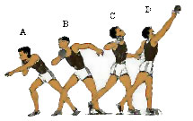
O2-LA (>3 min) |  |  | LA-O2(10-120) |  |  | ATP-CP+ LA (3-10) |  |  |  | ATP-CP (<3 Sec) |  | Metabolic demand (%)
exercise | muscle |  |  |  | contraction |  |  | joint |  | Action |  | Biomechanical demand
 | Common site |  |  | Mechanism |  |  | Contact/noncontact |  |  |  | Body system | Injury risk

