Plank fitness
Part one: Core plank moves
Chapter one: Full plank
1- Full plank | 2- Knee to chest | 3- Twisted knee to chest
4- Mountain climber | 5- Spider-man | 6- Spinal balancing
7- Modified spinal balancing | 8- Stepping feet out from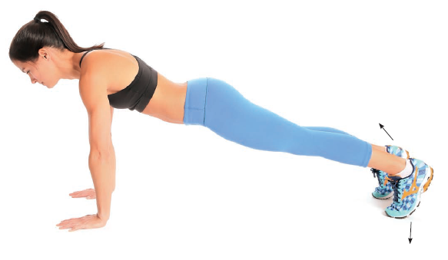 | 9- Alternate stepping feet out from
10- Pulsing | 11- One arm | 12- Walks
13- Three point knee to chest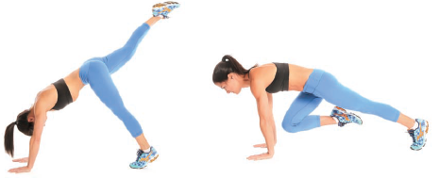 | 14- Arm reach front and back  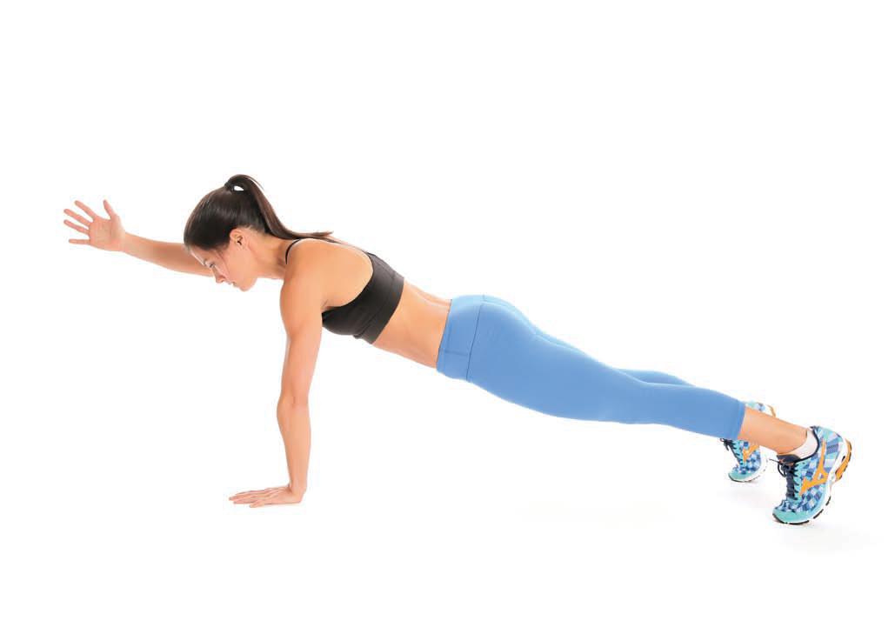 | 15- Donkey kicks
16- Modified donkey kicks | 17- Inchworms | 18- Walkout
19- Around the world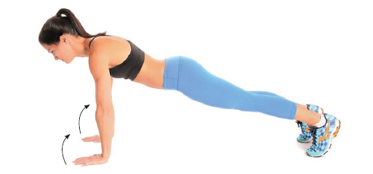 | 20- Shoulder tap
Chapter two: Side plank
21- Side full | 22- Foot taps | 23- Side plank with hip dips
24- Tree | 25- Leg raise | 26- Star
27- Bow | 28- Side plank with knee crunches | 29- Push up side plank
Chapter three: Forearm plank
30- Full forearm | 31- Rocking | 32- Knee taps
33- Hip drops | 34- Crossover | 35- Around the world marching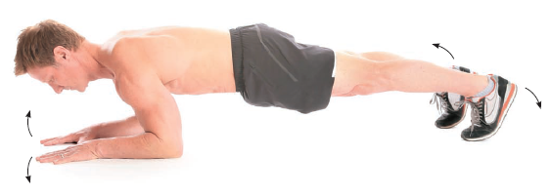
36- Dolphin | 37- Dolphin push-up
Chapter four: Side forearm plank
38- Full side forearm | 39- Wrist grab | 40- Hip dips forearm
41- Rolling
Part two: Unstable surface plank
Chapter five: Stability ball planks
42- Full stability ball | 43- Supported side | 44- Forearm
45- Side forearm | 46- Balancing | 47- Knee tucks
48- Walks | 49- Balancing side forearm | 50- Stir the pot  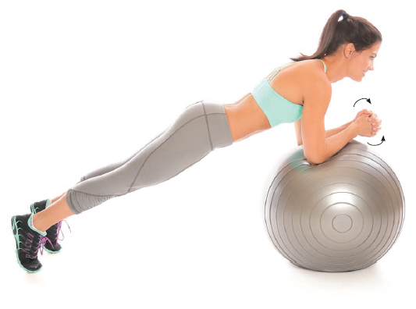
51- Reverse | 52- Modification reverse
Chapter six: Bosu trainer planks
53- Full bosu | 54- Flipped | 55- Walks bosu
56- Side forearm bosu | 57- Side forearm with knee crunches
Chapter seven: Medicine ball plank
58- Full medicine ball | 59- Double | 60- Rolling
61- Leg lift | 62- Cheetah | 63- Side
Part three: planks with equipment + plyometric
Chapter eight: planks with weights
64- Dumbbell punch | 65- Dumbbell rows | 66- Dumbbell triceps kickbacks
67- Full plank with weight | 68- Side plank with weight | 69- Star side
70- Stability ball chest Press | 71- Stability ball chest fly | 72- Stability ball overhead extension
73- Forearm Plank Plate
Push + Pull
Chapter nine: Plyometric planks
74- Lateral hopping | 75- Ski jump | 76- Planks jack  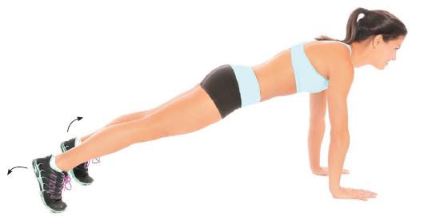
77- Jogging | 78- Mountain climber Push- ups | 79- Frog jump
Chapter ten: Glider planks
80- Forearm hand side | 81- Forearm body saw | 82- Forearm hip abduction +  Adduction  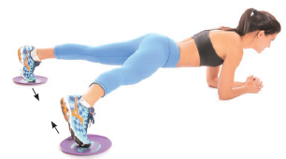
83- Knee to chest | 84- Twisted knee to chest | 85- Skiing
86- Crunch | 87- V-Up
Part four: Reverse, stretching + extra credit planks
Chapter eleven: Reverse planks
88- Table | 89- Reverse plank | 90- Leg lift
91- Table kicks | 92- Table crunch twist | 93- Bridge
94- Forearm | 95- Gliding disk slide-through
Chapter twelve: Stretching planks
96- Mermaid | 97- Revolved side | 98- Modified side with a Reach
99- Balancing modified side | 100- Bound modified | 101- Side to side gate
102- Flowing
Chapter thirteen: Extra credit planks
103- Medicine ball and bosu | 104- Medicine ball and bosu modified | 105- Bosu and stability ball
106- Bosu + gliding disk mountain climber

