Core Exercises
back extension | two lateral planks | prone bridge test
inertial  rotational testing | Functional Star Excursion Balance Test | Functional Star Excursion Balance Test
Functional Star Excursion Balance Test | forward throws | forward throws
 | .
backward throw | backward throw | lateral throws

Core Exercises
lateral throws | leaning back into a supine position | moving the body upward with arms  extended overhead
Push-ups of increasing complexity and instability | Push-ups of increasing complexity and instability | Push-ups of increasing complexity and instability
Push-ups of increasing complexity and instability | shoulder fly | Bicycle Crunch

Core Exercises
Bicycle Crunch |  | Reverse Crunch |  |  | Reverse Crunch
Reverse Crunch(To increase intensity, place hands behind the head or overhead) |  | Bird Dog |  |  | Bird Dog
Reverse Pendulum |  | Reverse Pendulum |  |  | Reverse Pendulum Medicine Ball Twister
Reverse Pendulum Medicine Ball Twister |  | Prone Plank |  |  | Prone Plank
Core Exercises
Prone Plank With Hip Extension |  |  | Stability Ball Plank to Pike-Up |  |  | Stability Ball Plank to Pike-Up
Side Bridge |  |  | Side Bridge |  |  | Modified Side Bridge (Forearm Bridge)
Press-Up |  |  | Press-Up |  |  | Glute–Ham Raise
 |  |  | 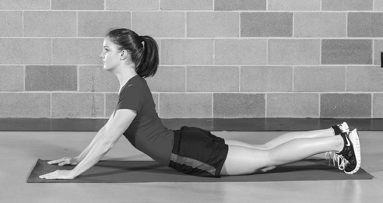
Glute–Ham Raise |  |  | Stability Ball Hyperextension |  |  | Stability Ball Hyperextension
Core Exercises
Stability Ball Hyperextension With Twist | Stability Ball Reverse  Hyperextension |  |  | Stability Ball Reverse  Hyperextension
Stability Ball Crunch | Stability Ball Crunch |  |  | Stability Ball Side Crunch
Stability Ball Side Crunch | Stability Ball Rotating Crunch |  |  | Stability Ball Rotating Crunch
Stability Ball Supine Bridge | Stability Ball Supine Bridge |  |  | Stability Ball Supine Bridge With Leg Curl

Core Exercises
Russian Twist | Russian Twist | Dumbb ell Side Bend
Dumbb ell Side Bend | Barbell Rollout | Barbell Rollout
Resistance Band Forward,  Backward, or Sideward Walkout | Resistance Band Forward,  Backward, or Sideward Walkout | Resistance Band Walkout With Hold

Core Exercises
Cable Kneeling Rope Crunch | Cable Kneeling Rope Crunch | Cable Kneeling Twisting Rope Crunch
Cable Kneeling Twisting Rope Crunch | Cable Side Bend | Cable Side Bend
Cable Low/High Woodchop | Cable Low/High Woodchop | Cable High/Low Woodchop

Core Exercises
Cable High/Low Woodchop | Cable Torso Rotation | Cable Torso Rotation
Side Double-Leg Lift | Side Double-Leg Lift | Diagonal Plate Chop
Diagonal Plate Chop | Diagonal Medicine Ball Chop | Woodchop Complex

Core Exercises
Woodchop Complex | Woodchop Complex | Woodchop Complex
Flutter Kick | Flutter Kick | Trunk Rotation
Trunk Rotation | Starfish With Resistance Bands | Starfish With Resistance Bands

Core Exercises
Starfish With Resistance Bands | Open-Book Rib Cage | Open-Book Rib Cage
Swimmer | Swimmer | Hanging Knee Raise
Hanging Knee Raise | Hanging Straight-Leg Raise | Hanging Knee Raise

Core Exercises
Hanging Knee Raise | Three-Point Samurai |  | Three-Point Samurai
Scissor Flutter Kick | Scissor Flutter Kick |  | Plate V-Up
Plate V-Up | Superman |  | Superman
Core Exercises
Jackknife |  | Jackknife |  | Leg Lower
 |  | 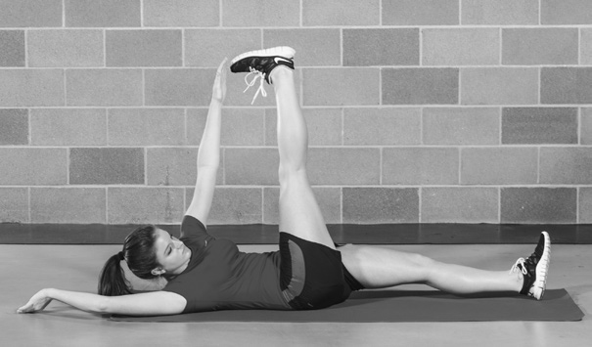
Leg Lower |  | working one leg at a time or both legs at once |  | Figure 8
Figure 8 |  | Dead Bug |  | Dead Bug

Core Exercises
Back Extension/Hyperextension |  |  | Back Extension/Hyperextension |  | Static Back Extension
Sit-Up |  |  | Sit-Up |  | Overhead Squat
Overhead Squat |  |  | Overhead Split Squat |  | Overhead Split Squat
Core Exercises
Medicine Ball Underhand Throw |  | Medicine Ball Underhand Throw |  | Medicine Ball Countermovement  Underhand Throw
Medicine Ball Countermovement  Underhand Throw |  | Medicine Ball Countermovement  Underhand Throw |  | Medicine Ball Backward  Overhead Toss
Medicine Ball Backward  Overhead Toss |  | Medicine Ball Pullover Pass |  | Medicine Ball Pullover Pass
Core Exercises
Medicine Ball Rotational Throw | Medicine Ball Rotational Throw |  |  | Medicine Ball Rotational Throw
Medicine Ball Countermovement  Underhand Throw | Medicine Ball Countermovement  Underhand Throw |  |  | Medicine Ball Countermovement  Underhand Throw

Core Exercises
Medicine Ball Backward  Overhead Toss | Medicine Ball Backward  Overhead Toss | Medicine Ball Pullover Pass
Medicine Ball Pullover Pass | Medicine Ball Rotational Throw | Medicine Ball Rotational Throw

Core Exercises
Medicine Ball Rotational Throw | Medicine Ball Rotational Throw |  |  |  |  | Medicine Ball Rotational Throw
Medicine Ball Rotational Throw | Medicine Ball Rotational Throw |  |  |  |  | Medicine Ball One-Arm Push
Medicine Ball One-Arm Push | Medicine Ball One-Arm Push |  |  |  |  | Medicine Ball Walking Lunge  With Rotation
Core Exercises
Medicine Ball Walking Lunge  With Rotation |  | Medicine Ball Overhead Throw |  |  | Medicine Ball Overhead Throw
Medicine Ball Crossover Step Throw |  | Medicine Ball Crossover Step Throw |  |  | Medicine Ball Crossover Step Throw
Medicine Ball Seated Chest Pass |  | Medicine Ball Seated Chest Pass |  |  | Medicine Ball Seated Twist
Core Exercises
Medicine Ball Seated Twist |  |  | Side-to-Side Twist | Side-to-Side Twist
Add resistance by holding a medicine ball in your outstretched arms as you  flex to each side |  |  | Medicine Ball Seated Figure 8 | Medicine Ball Seated Figure 8
Medicine Ball Seated Figure 8 |  |  | Medicine Ball Seated Figure 8 | Medicine Ball Seated Trunk Rotation

Core Exercises
Medicine Ball Seated Trunk Rotation | Medicine Ball Lunge Figure 8 | Medicine Ball Lunge Figure 8
Medicine Ball Lunge Figure 8 Throw | Medicine Ball Standing Figure 8 | Medicine Ball Standing Figure 8
Medicine Ball Standing Figure 8 | Medicine Ball Standing Figure 8 | Medicine Ball Partner  Sp eed Rotation

Core Exercises
Medicine Ball Partner  Sp eed Rotation | Medicine Ball Twisting Wall Toss |  |  | Medicine Ball Twisting Wall Toss
Medicine Ball Slam | Medicine Ball Slam |  |  | Medicine Ball Rotational Slam
Medicine Ball Rotational Slam | Angled Barbell Rotation |  |  | Angled Barbell Rotation
Core Exercises
Angled Barbell Deadlift to Press |  | Angled Barbell Deadlift to Press | Suspended Backward Row
Suspended Backward Row |  | Bully | Bully
Slide-Board Thrust |  | Slide-Board Thrust | Slide-Board Mountain Climber

Core Exercises
Slide-Board Mountain Climber

