KETTLEBELLS
FOR WOMEN

DEADLIFTS
DEADLIFT
START  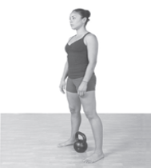 | 1  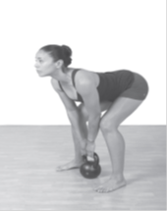 |  | 2  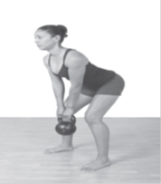 |  | 3  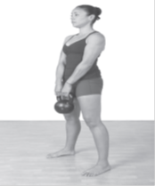
DOUBLE SUITCASEB DEADLIFT
START  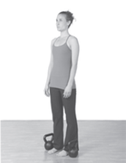 | 1  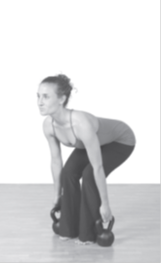 |  | 2  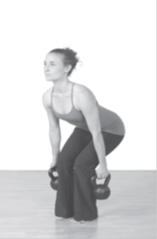 |  | 3  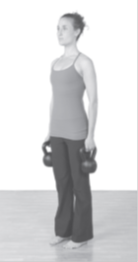
SUMO DEADLIFT
START  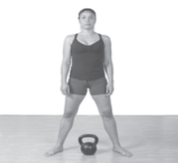 |  | 1  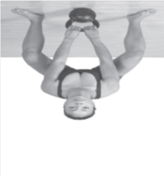 |  | 2  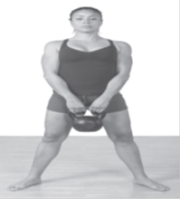
SINGLE- LEG DEADLIFT
START  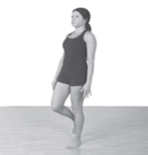 |  | 1 |  | 2

SINGLE-ARM SINGLE-LEG DEADLIFT
START  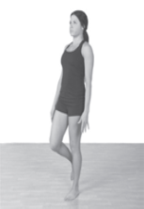 |  | 1 |  | 2
SINGLE BELL IN FRONT |  |  | DOUBLE-BELL SINGLE-LEG DEADLIFT
START | 1 |  | START |  | 1
SWINGS
ARM SWING
START | 1 |  | 2 |  | 3
ARM SWING
START |  | 1 |  | 2

ALTERNATING SWING
START |  |  |  | 1  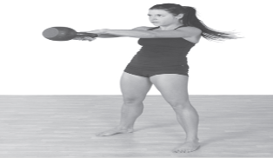
DOUBL SWING
START  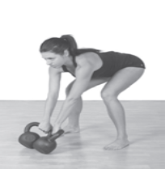 |  | 1 |  | 2 |  | 3
CLEANS
CLEANS
START  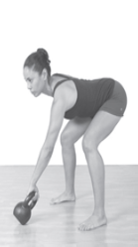 | 1 |  | 2 |  | 3 |  | 4

CHEAT CURL
START | 1 |  | 2 |  | 3
RACK WALK
START |  | 1 |  | 2
BOTTOMS-UP CLEAN
START |  | 1 |  | 2
Overhead Presses
MILITARY PRESS
START |  | 1 |  | 2

SEEAW PRESS
START |  | 1 |  | 2
BOTTOMS-UP PRESS
START | 1 |  | 2 |  | 3
PUSH PRESS
START | 1  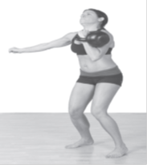 |  | 2 |  | 3
SEATED PRESS
START | 1 |  | 2 |  | 3

TALL KNEELING PRESS
START | 1 |  | 2
HALF KNEELING PRESS
START | 1 |  | 2
WAITER WALK
START |  | 1
Windmills
BODYWEIGHT WIDNMILL
START | 1 |  | 2

WINMILL(BOTTOM)
START |  | 1 |  | 2
WINDMILL(TOP)
START |  | 1 |  | 2
WINDMILL(DOUBLE)
START | 1 |  | 2 |  | 3
Push-Ups
BODYWEIGHT PUSH-UP
START |  | 1 |  | 2

DOUBLE-BELL PUSH-UP ON KNEES
START |  | 1 |  | 2
DOUBLE-BELL PUSH-UP
START |  | 1 |  | 2
SINGLE-BELL DIAMOND PUSH-UP
START |  | 1 |  | 2
DOUBLE-BELL DIP
START |  | 1 |  | 2
Floor Presses
FLOOR SIDE ROLL PICK-UP METHOD(1 BELL)
START | 1 |  | 2 |  | 3

FLOOR SIDE ROLL PICK-UP METHOD(2 BELL)
START  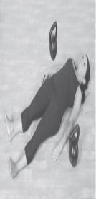 | 1 | 2
3 | 4 | 5
CHEST PRESS( SINGLE BELL IN THE MIDDLE)
START | 1 | 2
ARM FLOOR PRESS
START | 1 | 2

SEESAW FLOOR PRESS
START |  | 1 |  | 2
Rows
RENEGADE ROW PREP
STEP 1:WIDE- LEG HIGH PLANK |  | STEP2:RENEGADE HOLD(ALTERNATING ONE-ARM PLANK |  | STEP3: 1-ARM PLANK HOLD
RENEGADE ROW
START | 1 |  | 2 |  | 3
SINGLE-ARM ROW
START |  | 1 |  | 2

STABILIZED PLANK SINGLE-ARM ROW
START |  | 1 |  | 2
DOUBLE BENT-OVER
START |  | 1 |  | 2
ALTERNATING BENT-OVER ROW
START | 1 |  | 2 |  | 3
Arm-Sculpting & -Strengthening Drills
TRICEP EXTENSION
START |  | 1 |  | 2
BICEPS CURL
START |  | 1 |  | 2

PULLOVER
START | 1 |  | 2
PULLOVER TO CRUNCH
START | 1 |  | 2
Core Exercises
JANDA SIT-UP
START | 1 |  | 2
SIDE PLANK
START |  | 1
RUSSIAN TWIST
START | 1 |  | 2

HOT POTATO
START |  |  |  | 1 |  |  |  |  |  | 2
FIGURE 8
START | 1 |  |  |  | 2 |  |  | 3 |  |  |  | 4
FIGURE 8 TO HOLD
START |  | 1 |  |  |  | 2 |  |  | 3 |  |  |  | 4
SQUAT
SQUAT
START |  |  | 1 |  |  |  | 2 |  |  |  | 3

GOBLET SQUAT VARIATION |  | FRONT SQUAT VARIATION |  |  | DOUBLE FRONT SQUARE VARIATION
OVERHEAD SQUAT
START |  | 1 |  |  | 2
SINGLE- LEG SQUAT ON BENCH
START |  | 1 |  |  | 2
DECK SQUAT
START | 1 |  | 2 | 3 |  | 4

Lunges
STATIONARY LUNGE

START | 1 |  | 2
STATIONARY LUNCH WITH BELL

START |  | 1
REVERSE LUNGE
START | 1 |  | 2
FORWARD LUNGE
START | 1 |  | 2

TACTICAL LUNGE
START | 1 |  | 2 |  | 3
KIKSTANDARD LUNGE
START |  | 1 |  | 2
High Pull
HIGH PULL
START |  | 1 |  | 2
3 |  | 4 |  | 5

Turkish Get-Ups
GET UP SIT UP
START | 1 | 2 | 3
TURKISH GET UP
START | 1 | 2 | 3
4 | 5 | 6 | 7
8 | 9 | 10 | 11

Snatch
SNATCH
START |  | 1 |  | 2
3 |  | 4 |  | 6
Warm-Up Exercises
MINI PLANK
START |  | 1 |  | 2
FLOOR BRIDGE
START |  | 1 |  | 2
SINGLE LEG FOOR BRIDGE
START | 1 |  | 2 |  | 3

SQUATTING HIP OPENER
TART |  |  | 1
HIP OPENER & GLUTE ACTIVATOR
START | 1 |  | 2 |  | 3
ANKLE MOBILITY
START |  | 1 |  | 2
SHOULDER & THORACIC MOBILITY DRILL
START |  |  | 1

HALO
START | 1 |  |  | 2 |  | 3 |  |  | 4
KNEELING HALO
START |  | 1 |  |  | 2 |  |  | 3
BODY WEIGHT SQUAT
START |  |  | 1 |  |  |  | 2
LATERAL LUNGE
START |  |  |  |  | 1

FARMER S WALK
START |  |  | 1
SQUAT THRUST
START | 1 | 2 |  | 3 | 4
BURPEE
START | 1 | 2 |  | 3 | 4
JUMPING JACKS
START |  |  | 1

HIGH PLANK
Joint Mobility Exercises
NECK MOBILITY: SIDE TO SIDE ROTATION
START |  | 1 |  | 2
NECK MOBILITY: EAR TO SHOULDER
START |  | 1 |  | 2
WRIST MOBILITY
START | 1 |  | 2 |  | 3
SHOULDER FIGURE 8
START |  | 1 |  | 2
3 |  | 4 |  | 5

KNEE LIRDEES
START |  | 1 |  | 2
HIP CIRCLES
START | 1 |  | 2 |  | 3
PELVIC TILTS
START |  | 1 |  | 2
ANCLE CIRCLES
START |  | 1 |  | 2

NECK MOBILITY
START |  | 1
Cool-Down Stretches
CHILD’S POSE AND STRETCH |  |  | HAPPY BABY HAMESTRING STRETCH
THORACIC/HIP FLEXOR/ QUAD STRETCH
START | 1 | 2 |  | 3
OBLIQUE AND LAT STRETCH
START |  | 1
SQUATTING FIGURE 4 GLUTE STRETCH

